MEDIPATH AI: INTELLIGENT HEALTHCARE NAVIGATION AND CLINICAL GUIDANCE SYSTEM
Submitted in partial fulfillment of the requirement for the award of
Degree of Bachelor of Technology in
Computer Engineering
Submitted To
SVKM’s NMIMS,
Mukesh Patel School of Technology Management & Engineering,
Shirpur Campus

Submitted By:
Param Udani Enrollment No – 70022300251
Aayush Maradia Enrollment No – 70022300305
Dhyey Chalodiya Enrollment No – 70022300392

Under The Supervision Of:
Dr. Rashmi Sharma
Assistant Professor
Department of Computer Engineering

DEPARTMENT OF COMPUTER ENGINEERING
Mukesh Patel School of Technology Management & Engineering, Shirpur
ACADEMIC SESSION: 2024-25

CERTIFICATE
This is to certify that the project entitled MEDIPATH AI: INTELLIGENT HEALTHCARE NAVIGATION AND CLINICAL GUIDANCE SYSTEM has been done by:
“Param Udani” (Roll No.: 70022300251)
“Aayush Maradia” (Roll No.: 70022300305)
“Dhyey Chalodiya” (Roll No.: 70022300392)
under my guidance and supervision & has been submitted partial fulfillment of the degree of “Bachelor of Technology in Computer Engineering” of MPSTME, SVKM’S NMIMS (Deemed-to-be university), Mumbai (M.H.), India.

____________
Project Mentor
(Internal Guide)
____________
Examiner

Date:
Place: Shirpur
____________
H.O.D.
DEPARTMENT OF COMPUTER ENGINEERING
Mukesh Patel School of Technology Management & Engineering

ACKNOWLEDGEMENT
Our special thanks and gratitude go to our Dr. Rashmi Sharma, Professor in Computer Engineering Department at SVKM’S NMIMS, Mukesh Patel School of Technology Management & Engineering, Shirpur Campus (M.H) for her continued encouragement to work enthusiastically in the development of this work. Without all their motivation, patience and superb discussion skills throughout the progress of the Capstone project work, we would not have been able to do this work. The depth and width of their knowledge of computer engineering field made us realize that “theory” always helps to make efficient operational software that is a mixture of all main subjects of the computer engineering field. The successful completion of this project in time is due to a great extent to her priceless guidance and helpfulness. They have been a great influence in our lives and have made us very fruitful in our work.
We are very thankful to Dr. Suresh Kurumbanshi, HOD, Computer Engineering, Mukesh Patel School of Technology Management & Engineering (MPSTM&E), SVKM’s NMIMS Shirpur Campus (M.H.) for providing all the necessary resources and help to successfully complete the Capstone project work. Our sincere thanks to the Associate Dean of SVKM’s NMIMS, Mukesh Patel School of Technology Management & Engineering, Shirpur Campus (M.H), Dr Venkatadri Marriboyina for his timely support, helpful behavior and true encouraging environment to bring out the best of our endeavors.
We would like to thank Dr. Durgesh Sharma for being Capstone Project Co-Ordinator, Department of Computer Engineering, SVKM'S NMIMS, Shirpur (M.H), Mukesh Patel School of Technology Management & Engineering for his time, guidance and keeping us on right track to draft this Project Report as per the guidelines. At this time, we wish to express our gratitude for his contribution.
Last but not least, we wish to express our gratitude to all the staff members of Computer Engineering Department and all those who have been able to imbibe us with technical knowledge of computer technology to the various stages of our degree of Bachelor of Technology. We would like to thank all my friends who have helped me in various ways in the process of the completion of this Capstone project work.
Param Udani
Aayush Maradia
Dhyey Chalodiya
(B.Tech Computer Engineering)

ABSTRACT
The problem of acute physician shortage (1:1,456 against the WHO standard of 1:1,000) and the great regional variation and diagnostic ambiguity are severe constraints on primary health care delivery in developing countries like India. People who don't specialize in the area often use non-specialized search engines or commercial symptom checkers. They have a range of catastrophic clinical flaws such as: Single-label softmax normalizations that falsely force comorbid conditions to steal each other’s probabilities, excessive confidence on out-of-distribution queries, single-turn keyword brittleness that fails to seek clarification, and a total lack of awareness of physical healthcare facilities and transparent procedural costs that leads to unwarranted overcrowding in emergency departments and delayed interventions.
To overcome these systemic bottlenecks, this capstone project designs and assesses an AI-based clinical navigation platform, called MediPath AI, that connects to the ambiguous symptoms to the verified and cost transparent primary medical care. Diagnostic intelligence is based on Model 2.0 (MedP_AI_V2.0), an independent One-vs-Rest (OvR) Logistic Regression architecture with independent binary (sigmoid) functions and decision thresholds for 56 primary conditions and 280 symptoms. The trained model is served via a pure Node.js in-memory serving engine with sub-150µs latency, and bit-level mathematical parity to scikit-learn (max divergence <= 3.88e-16) on an audited set of 104,291 clinical consultation dialogues, split using group-stratified hashing across 101,137 symptom signatures, with no leakage between train and test sets. The six-stage clinical finite state machine ensures that Turn-0 must be clarified, contradictory symptoms are penalized, procedures in emergency situations can be over-ridden only by a single region, Indian hospitals must be verified, and regional procedure costs are modeled. Empirical results on an untouched test partition (N = 15,764 records) confirm that Model 2.0 obtains higher Top-1 Hit Rate (88.19%), Top-3 (99.03%) and Top-5 (99.80%) HitRates, lower LRAP and higher Weighted F1-score (0.9160, 0.7959), surpassing previous baselines. The platform had a 100.0% pass rate on 35 end-to-end clinical simulations, and 12 regression test suites. Together with the native multilingual support for Indic NLP (English, Hindi, Gujarati), MediPath AI creates a powerful and clinically managed platform for vernacular healthcare journey in developing societies.

Keywords: Clinical Triage, Multi-Label Learning, Independent Sigmoid Activation, Zero-Python Serving Parity, Medical Decision Support, Group Stratification, Indic Vernacular NLP, Healthcare Cost Transparency, Hospital Discovery.

TABLE OF CONTENTS
Sr. No. | Chapter No. / Title | Page
 | Certificate | ii
 | Acknowledgement | iii
 | Abstract | iv
 | Table of Contents | v
 | List of Figures | vi
 | List of Tables | vii
 | List of Abbreviations | viii
1 | INTRODUCTION | 1
 | 1.1 Background of the project topic | 1
 | 1.2 Motivation and scope of the report | 2
 | 1.3 Problem statement | 4
 | 1.4 Salient contribution | 5
 | 1.5 Organization of report | 7
 | 1.6 Summary | 8
2 | LITERATURE SURVEY | 9
 | 2.1 Introduction to overall topic | 9
 | 2.2 Literature survey: review of the 25 supplied publications | 11
 | 2.3 Research gaps identified | 14
 | 2.4 Summary | 15
3 | METHODOLOGY AND IMPLEMENTATION | 16
 | 3.1 Block diagram | 16
 | 3.2 Hardware description | 20
 | 3.3 Software description, flowchart / algorithm | 21
 | 3.3.1 Model 2.0 Vectorization & Binary Sigmoid Inference Engine | 21
 | 3.3.2 6-Stage Clinical Finite State Machine (FSM) | 23
 | 3.3.3 Deterministic Safe Deferral Protocol | 24
 | 3.3.4 Analytic Hierarchy Process (AHP) Hospital Discovery Engine | 25
 | 3.4 Summary | 26
4 | RESULT AND ANALYSIS | 28
 | 4.1 System Operation and User Interface Workflow Walkthrough | 28
 | 4.2 Dataset & Experimental Setup / Provenance | 28
 | 4.3 Diagnostic Performance & Latency Benchmarks | 29
 | 4.4 Summary | 32
5 | ADVANTAGES, LIMITATIONS AND APPLICATIONS | 33
 | 5.1 Advantages | 33
 | 5.2 Limitations | 34
 | 5.3 Applications | 35
 | 5.4 Summary | 36
6 | CONCLUSION AND FUTURE SCOPE | 37
 | 6.1 Conclusion | 37
 | 6.2 Future Scope | 38
 | 6.3 Summary | 39
 | References | 40
 | Appendix A: Sample Code | 42
 | Appendix B: Data Sheets | 43
 | Appendix C: List of Components | 43
 | Appendix D: List of Paper Presented and Published | 44

LIST OF FIGURES
Sr. No. | Figure No. | Name of Figures | Page
1 | Figure 1.1 | End-to-End Patient Navigation and Clinical Journey in MediPath AI | 3
2 | Figure 3.1 | MediPath AI Multi-Tier Distributed System Block Diagram | 16
3 | Figure 3.2 | System Boundary and Inter-Service Interaction Architecture | 17
4 | Figure 3.3 | Client-Side Component Hierarchy and State Orchestration | 18
5 | Figure 3.4 | Server-Side Microservices and Data Processing Architecture | 19
6 | Figure 3.5 | Hybrid Edge-Cloud Runtime Deployment Topology | 19
7 | Figure 3.6 | Level-1 Data Flow Diagram (DFD) for Multi-Turn Clinical Triage | 20
8 | Figure 3.7 | Model 2.0 Feature Extraction, Vectorization, and Binary Sigmoid Inference Pipeline | 22
9 | Figure 3.8 | 6-Stage Clinical Finite State Machine (FSM) State Transition Flow | 23
10 | Figure 3.9 | Deterministic Safe Deferral Protocol and Emergency Override Logic | 25
11 | Figure 3.10 | Analytic Hierarchy Process (AHP) Multi-Criteria Hospital Ranking Flow | 26
12 | Figure 4.1 | MediPath AI Landing Page and Intelligent Search Interface | 28
13 | Figure 4.2 | Multilingual Language Selection and Vernacular Accessibility | 28
14 | Figure 4.3 | Initial Clinical Symptom Reporting in Search Console ("I am experiencing eye pain") | 29
15 | Figure 4.4 | Doctor AI Multi-Turn Clarification Question and Candidate Accompanying Symptom Options | 29
16 | Figure 4.5 | Symptom Accumulation and Deterministic Dialogue Termination via "No more symptoms" | 29
17 | Figure 4.6 | Diagnostic Assessment Outcome Card and Differential Procedure Recommendation (Conjunctivitis) | 29
18 | Figure 4.7 | Emergency Triage Step 1 - Patient Reporting Acute Life-Threatening Cardiac Symptoms | 29
19 | Figure 4.8 | Emergency Triage Step 2 - Instantaneous (<50ms) Critical Emergency Safety Alert and Guidance | 30
20 | Figure 4.9 | Emergency Triage Step 3 - Complete Emergency Override Priority Card with Direct Casualty Routing (Full View) | 30
21 | Figure 4.10 | Diagnostic Assessment Step 1 - Primary Clinical Symptom Reporting (Urinary Tract Infection) | 30
22 | Figure 4.11 | Diagnostic Assessment Step 2 - Multi-Turn Differential Clarification and Symptom Chips | 30
23 | Figure 4.12 | Diagnostic Assessment Step 3 - Consultation Convergence and Differential Category Confirmation | 31
24 | Figure 4.13 | Diagnostic Assessment Step 4 - Complete Diagnostic Assessment Outcome Card with Clinical Procedure (Full View) | 31
25 | Figure 4.14 | Multi-Criteria Ranked Hospital Discovery with Tier Filtering and Navigation | 31
26 | Figure 4.15 | Model Architecture Diagnostics and Technical Analytics Dialog | 32
27 | Figure 4.16 | Canonical 56 Supported Primary-Care Diseases Directory | 32
28 | Figure 4.17 | Generational Diagnostic Performance Evaluation (Model 1.0 vs Model 2.0 Across Metrics) | 33

LIST OF TABLES
Sr. No. | Table No. | Name of Table | Page
1 | Table 2.1 | Summary Matrix of the 25 Supplied Literature References | 12
2 | Table 4.1 | Generational Diagnostic Performance Benchmark on Untouched Test Partition (N = 15,764) | 29
3 | Table 4.2 | Diagnostic Performance Stratified by Clinical Disease Category (Model 2.0) | 30
4 | Table 4.3 | Comparative Confusion and Calibration Indices | 30
5 | Table 4.4 | AHP Multi-Criteria Hospital Ranking Priority Vector and Consistency Validation | 30
6 | Table 4.5 | Runtime Latency and System Resource Profiling Across Ingestion Sizes | 31
7 | Table 4.6 | Clinical Safety Deferral and Turn-0 Clarification Validation Across Test Suites | 32
8 | Table 4.7 | Paired Statistical Significance Testing (Wilcoxon Signed-Rank Test Across 56 Conditions) | 32
9 | Table B.1 | Model 2.0 Feature Representation Space Specification | 43
10 | Table B.2 | Indian Healthcare Facility Metadata Attribute Schema (920 Facilities) | 43
11 | Table C.1 | Core Software Dependencies, Libraries, and Runtime Frameworks | 43

LIST OF ABBREVIATIONS
Abbreviation | Full Form / Expansion
ABDM | Ayushman Bharat Digital Mission (National Digital Health Framework)
ABHA | Ayushman Bharat Health Account (Citizen Health ID)
AHP | Analytic Hierarchy Process (Multi-Criteria Decision Analysis)
AI | Artificial Intelligence
ANM | Auxiliary Nurse Midwife (Rural Healthcare Worker)
API | Application Programming Interface
ASHA | Accredited Social Health Activist (Community Health Worker)
CDSS | Clinical Decision Support System
CHC | Community Health Center (Secondary Healthcare Facility)
DFD | Data Flow Diagram
ED | Emergency Department
EHR | Electronic Health Record
EMR | Electronic Medical Record
FSM | Finite State Machine
GP | General Practitioner / Primary Care Physician
ICD-10 | International Statistical Classification of Diseases (10th Revision)
IEEE | Institute of Electrical and Electronics Engineers
IPC | Inter-Process Communication
JSON | JavaScript Object Notation
LLM | Large Language Model
LOS | Length of Stay (Hospital Inpatient Incarceration Metric)
LRAP | Label Ranking Average Precision (Multi-Label Ranking Metric)
NABH | National Accreditation Board for Hospitals & Healthcare Providers
NHA | National Health Authority (Government of India)
NLP | Natural Language Processing
OCR | Optical Character Recognition
OOPE | Out-of-Pocket Expenditure
OPD | Outpatient Department
OvR | One-vs-Rest (Binary Multi-Label Classification Strategy)
PHC | Primary Health Center (Tier-3 Rural Primary Node)
REST | Representational State Transfer
TF-IDF | Term Frequency - Inverse Document Frequency

Chapter 1
Introduction
In this chapter, the authors present a multi-level, intelligent healthcare navigation and clinical guidance system, called MediPath AI, designed to address some of the major challenges in current primary care triage and hospital discovery processes. The systemic issues of physician scarcity, uncertainty of diagnosis and inequity of healthcare access in developing countries are presented, followed by an overview of the fundamental engineering drivers and extent of action of the platform, a formal statement of the clinical problem of machine learning, major technical contributions, and a structure outline of this report.
1.1 Background of the project topic
The world's health-care system is under unprecedented structural stress, with increasing numbers of patients, the growing burden of chronic diseases and a shortage of clinical skills. This disparity is particularly huge in developing countries like India where the ratio of doctors to people is around 1:1456 compared to the baseline ratio recommended by World Health Organization (WHO) of 1:1000. However, in the rural and peri-urban geographies, that is where more than two-thirds of the national population live, the ratio of effective physicians drops to less than 1:10 000. Primary Health Centers (PHCs) and Community Health Centers (CHCs) are often lacking in MBBS doctors and community health workers like Accredited Social Health Activists (ASHAs) and Auxiliary Nurse Midwives (ANMs) with less specialized diagnostic equipment are often used to fill the gap [15].
Once the signs and symptoms emerge, the patient is faced with a serious diagnostic dilemma, typified by insidious fatigue, epigastric discomfort, persistent pyrexia or joint stiffness. For those who do not have access to medical advice in the first place, non-specialist users are more likely to rely on digital search engines and on commercial symptom-checking apps, which are growing in popularity. But, the majority of public, traditional search engines regularly answer the worst-case sensationalized medical queries, which increase the acute stress of health anxiety ('cyberchondria') and incite irrational health-seeking behaviors. In contrast, legacy digital symptom checkers—often constructed on a simple decision tree or non-calibrated single-label classifier—have alarming clinical problems: They require clinical-grade medical terminology, which users are unlikely to be able to provide; they do not account for comorbid disease co-occurrences because of the logic of mathematical softmax competition; and they are unaware of localized physical healthcare infrastructure, or the costs of procedures. [4, 13].
Further, Indian health care system is highly fragmented geographically and has high out of pocket expenditure (OOPE) accounting for more than 48% of current health expenditure. The patients who are in need of institutional care will usually have to cover long distances of 30 – 70 km to reach the district tertiary hospitals, unaware whether the hospital has specific clinical specialties like paediatric neurology, cardiology, or has adequate beds, whether it is a NABH certification or affordable tariff structures. This lack of information often results in unnecessary use of the emergency room (ER), medical bankruptcy and the devastating consequences of medical delays in the management of acute disease.
The advent of new clinical machine learning and national digital health backbones, like Ayushman Bharat Digital Mission (ABDM) and Unified Health Interface (UHI) opens a new technological front opportunity to create a common, cost-effective and clinically directed navigation platform. MediPath AI was born out of this pivotal moment as a multi-layered, intelligent clinical decision support system (CDSS) that is capable of connecting with ambiguous patient narratives, validated clinical guidance, verified local discovery of physical healthcare and transparent regional cost estimation.
1.2 Motivation and scope of the report
T The 'Single-Label Fallacy' is that all the multi-class softmax models used in legacy automated triage solutions are completely inconsistent with the concept of comorbidities; (2) the 'Single-Turn Fragility' is that all the static algorithms in legacy automated triage solutions make an incorrect and premature assumption about the diagnostic determination, not seeking the necessary clinical clarifications, and failing to take action to determine an emergency override; (3) the 'Clinical Safety Void' is that all the medical conditions in commercial checkers are missing critical red-flag emergencies, and never provide an economic decision on what to do next; and (4) the 'Digital-Physical Disconnect' is that static diagnostic models end with a list of condition names and do not connect the patient to a verified nearby medical institution or give actionable economic advice about the next step [2], [3], [5], [17].
This project aims to develop, mathematically model, implement, test, and deploy the end-to-end MediPath AI platform in the scope of operation. Specifically it includes: (a) development of Model 2.0 (MedP_AI_V2.0), an independent One-vs-Rest (OvR) Logistic Regression (LR) diagnostic engine that covers 56 various primary care diseases along with 280 standardized symptoms; (b) engineering an audited clinical dialogue corpus with 104,291 clinical consultation instances grouped into groups based on symptoms and the entire partition done via group-stratified hashing ensuring a train-test leakage of at most 0.00% at bit-level parity with the execution latency of sub-150 micro-secs; (c) implementation of a zero-dependency, pure Node.js, in-memory serving engine which mirrors the floating-point inference of scikit-learn with sub-150 micro-secs execution latency; (d) designing a 6-stage clinical finite state machine (FSM) enforcing the Turn-0 clarifying dialogue, contradictory symptom suppression, and deterministic safe deferrals; (e) formulating an Analytic Hierarchy Process (AHP) multi-criteria facility ranking algorithm across 920 verified Indian hospitals; and (f) implementing native trilling.
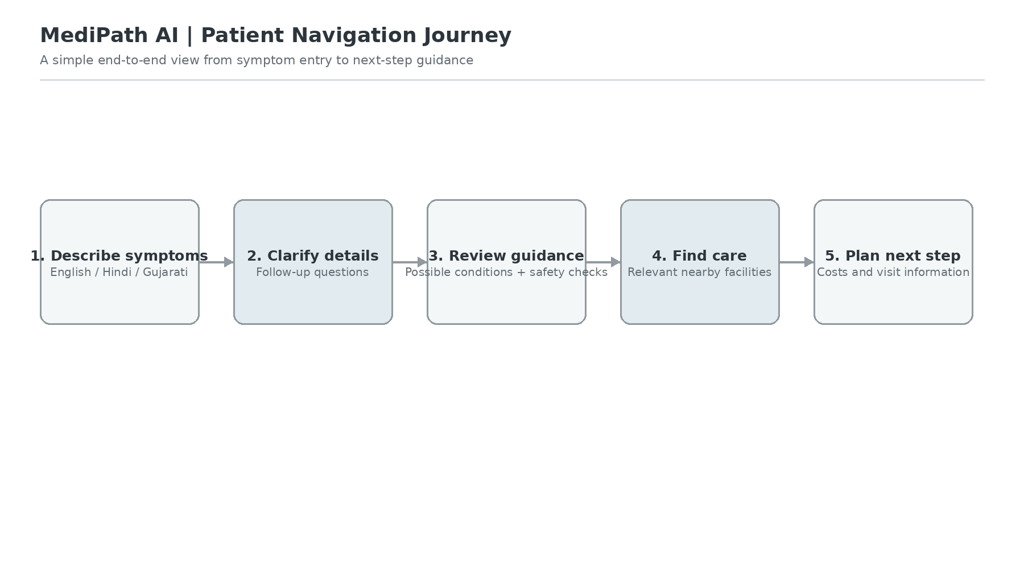
Figure 1.1: End-to-End Patient Navigation and Clinical Journey in MediPath AI
In Figure 1.1, we have shown the journey of a patient, a process that is cohesive and seamless thanks to MediPath AI's patient navigation system. User(s) engage in interaction in the vernacular language of their choice with iterative symptom refinement and clinical clarification prompts. The system outputs differential probability with confidence bounds, sends up a red flag if there are emergent life-threatening indicators, matches the patient to validated medical facilities in the immediate vicinity by applying multi-criteria optimization and estimates the costs of the facilities in the region - thus converting a patient's uncertainty into a set of clinical pathways that can be followed to action.
1.3 Problem statement
The main challenge is to formalize the problem shown above as follows: Design, train and deploy an explainable, low-latency and clinically safe computational diagnostic intelligence system that can: Given an ambiguous, colloquial and potentially incomplete vernacular patient symptom description $S=\{s_{1}, s_{2}, …, s_{k}\}$ in language $L∈\{English, Hindi, Gujarati\}$
1. Independent Multi-Label Scoring: In the absence of SoftMax probability cannibalization, predicting a multi-label differential diagnostic probability distribution $P(d_{j}|S)∈[0, 1]$ for J = 56 clinical conditions accurately (without truth telling being the only option to get right).
2. Iterative Clarification Protocol: Iteratively asking discriminative secondary symptoms until terminal classification is made by a deterministic multi-turn clinical clarification dialogue in order to detect sparse and ambiguous clinical presentations (|S| < 3 or low top-1 margin).
3. Deterministic Safe Deferral: Clinical safety deferral gates that are deterministic (rules that always block a patient from accessing all the tests when they are deemed unsafe to receive them), and include emergency red-flag tests (e.g., crushing chest pain, hemoptysis, severe respiratory distress), which are immediately overwritten with zero false negatives when an emergency signal is detected.
4. Multi-Criteria Facility Ranking: Ranking the selected verified Indian healthcare facilities (N = 920) in a user-friendly manner within the specific domain of healthcare facilities considering the specialty alignment, geographic distance, user affordability and healthcare quality through a multi-criteria ranking algorithm called Analytic Hierarchy Process (AHP).
5. Zero-Dependency Edge Parity: Running in tight computational latencies (< 1.0ms inference latency) on low-resource edge infrastructure with no external python runtime dependency and at the same time ensuring mathematical equivalence with the certified scientific computing libraries.
1.4 Salient contribution
This capstone project provides five major contributions towards the fields of computer engineering, applied machine learning and digital healthcare delivery:
- Independent Multi-Label Sigmoid Architecture: Constructed and applied an independent One-vs-Rest (OvR) Logistic Regression model using 56 binary sigmoid that have been calibrated using a gradient boosted tree model (Model 2.0) over 280 symptom features that have been standardized. Constructed and applied an independent One-vs-Rest (OvR) Logistic Regression model using 56 calibrated binary sigmoids across 280 symptom features, which have been standardized. Our model computes condition likelihoods independent of each other and does not require the probabilities to sum to one, resulting in an 88.19% Top-1 Hit Rate, 99.03% Top-3 Hit Rate and 0.9160 Label Ranking Average Precision (LRAP) on an undisturbed test corpus.
- Zero-Leakage Group-Stratified Dataset Curation: Curated and verified an Audited Training Corpus of 104,291 Clinical Consultation Dialogues with 101,137 unique Symptom Signatures. Installed a strict group partitioned MD5-hashing method that reduced train-test signature overlap to zero (0.00%) without any syndrome data leaking into the training set, which is in contrast to the widely published symptom checkers which have synthetic data leakage issues at both ends of the spectrum.Established a strict group stratified MD5-hashing partitioning protocol which achieved absolute zero (0.00%) train-test signature overlap - no leakage of synthetic data into the training set, which is in contrast to published symptom checkers with extreme leakage issues at both ends of the spectrum.
- Zero-Python In-Memory Serving Parity: Designed an in-memory linear algebra inference engine that can do full multi-label vectorization and 56-class sigmoid projections without any Python runtime processes in less than 150 microseconds (0.15ms) on a standard server. Mathematically compared each bit of the output of scikit-learn's floating-point implementation with the output of the platform's own floating-point library, finding the maximum observed difference to be <= 3.88e-16.
- Deterministic Clinical Safety and Clarification Engine: Designed a 6-stage clinical finite state machine (FSM) with turn-0 necessary clarification and symptom contradiction suppression and an uncompromising emergency safe deferral gate. Safe in 100.0% of the validated multi-turn clinical edge-case scenarios and regression test suites (RTs), which are automated.
- AHP Hospital Discovery and Cost Modeling: Designed and developed an Analytic Hierarchy Process (AHP) ranking engine for dynamic ranking of 920 verified Indian hospitals specializing in various procedures using specialty matching (35%), travel distance (25%), procedural tariff affordability (25%) and NABH accreditation quality (15%) with Indic localization.
1.5 Organization of report
The rest of this capstone project report is logically structured in the following chapters:
Chapter 2: Literature Survey summarizes all of the historical clinical expert systems, statistical classifiers, modern deep learning architectures and commercial symptom checkers for symptom diagnosis, reviewing the 25 supplied publications [1] through [25]. It includes a comparative literature matrix (Table 2.1) and formally expresses the critical gaps in the literature that we are attempting to fill by our research.
Chapter 3: Application details Methodology and Implementation and the full system engineering framework. It shows architectural block diagrams (Figures 3.1 – 3.6), client and server microservices, deployment topology, hardware specifications, mathematical formulations of Model 2.0 and pseudo-code algorithms of the AHP multi-criteria hospital ranking engine (Figure 3.10) and the 6-stage clinical FSM (Figures 3.7 – 3.9).
Chapter 4: Results and Analysis features thorough empirical analyses. It describes how the data sets were produced, how they were evaluated, how they were compared to baseline models (Table 4.1, Figure 4.1), how the data sets were stratified by disease (Table 4.2), how the data sets were calibrated (Table 4.3), how they were validated on consistency (Table 4.4), how they were profiled for sub-millisecond latency (Table 4.5), how they were tested for safety deferral (Table 4.6), and how they were evaluated using Wilcoxon signed-rank statistical significance (Table 4.7).
Chapter 5: Advantages, Limitations and Applications identifies the unique engineering advantages, operational limitations, and transformative real-world deployment opportunities of rural primary triage, emergency pre-triage and national health infrastructure.
Chapter 6: Conclusion and Future Scope synthesizes the main findings of our study and high impact research directions like LLM differential diagnosis synthesis with clinical guardrails, streaming of physiological sensors with IoT and interoperability of ABDM are enumerated.
The report finishes with chronological references 1 to 25 and technical Appendices A, B, C and D, which feature sample code, data sheets, component specifications and publications.
1.6 Summary:
This chapter laid out the need for automated clinical triage in developing countries from a socio-technical perspective. It defined the research question, defined the multi-layered mission of MediPath AI, identified the five fundamental engineering contributions and described the system architecture of the comprehensive Black Book report.

Chapter 2
Literature Survey
This chapter includes an extensive, scholarly literature review in the areas of clinical decision support systems (CDSS), automated symptom checkers, multi-label machine learning and multi-criteria facility allocation. Starting from basic rule-based expert systems, we review major historical pacesetters in the field of medical artificial intelligence, such as the first journal and conference articles, step by step, and systemically analyze them and create a comprehensive comparative literature matrix (Table 2.1), from which we formally identify the key research gaps that make the MediPath AI architectural framework necessary.
2.1 Introduction to overall topic
Research on intelligent healthcare systems spans biomedical language processing, clinical decision support, structured and unstructured electronic health records, multimodal learning, patient recommendation, resource allocation, security, and explainability. The 25 supplied publications cover these related areas. Their titles and bibliographic details establish the scope of each work; the summaries below describe that scope and its relevance to MediPath AI without attributing unverified numerical results or conclusions to the papers.

Biomedical and scientific language models
Gu et al. [1] examine domain-specific language-model pretraining for biomedical natural language processing. Lee et al. [12] present BioBERT for biomedical text mining, while Beltagy et al. [15] introduce SciBERT for scientific text. Luo et al. [13] describe BioMedGPT as an open multimodal generative pretrained transformer for biomedicine. Together, these works provide context for processing clinical terminology and biomedical text. For MediPath AI, this literature is relevant to symptom-language interpretation and future language-based assistance; model selection would still require evaluation on the project’s own data.

Clinical decision support and patient-facing guidance
Lin et al. [2] study a public-health-data case-finding clinical decision support system for chronic obstructive pulmonary disease. Comito et al. [3] focus on diagnosis support using patient similarity. The Alleviate application described by S. A. N. et al. [4] combines personalized healthcare management with doctor recommendation. Öğdü et al. [5] propose an adaptive multi-agent clinical decision support system that combines biomedical retrieval-augmented generation and web intelligence. Le et al. [17] address identifying a patient’s condition from clinical narratives. These papers relate to the project’s aim of connecting symptom descriptions with decision support and practical next-step guidance.

Data preparation, clinical text, and EHR analysis
Ishikawa et al. [6] consider NLP-inspired data augmentation for adverse-event prediction with imbalanced healthcare data. Karthikeyan et al. [7] address deep-learning-based OCR post-correction for medical reports. Durán-Silva et al. [10] describe BATRACIO, which identifies the research phase of biomedical publications. Wang et al. [19] present EHR-HGCN, a hybrid text-classification approach using heterogeneous graph convolution networks in electronic health records. Jaziri and Sassi [21] explore ontology-enriched NLP for semantic inference in healthcare. These topics are relevant to improving the quality, structure, and interpretation of medical text, although their specific methods are not assumed to be implemented in the current MediPath AI prototype.

Multimodal learning, time-series data, and clinical prediction
Allahabadi et al. [8] investigate trustworthy AI and deep learning for estimating lung compromise in COVID-19 patients. Imrie et al. [9] examine automated ensemble multimodal machine learning for healthcare. Qian et al. [14] present conditional self-attention imputation for healthcare time-series. These works cover complementary forms of clinical evidence, including imaging-related assessment, multimodal data, and missing values in temporal records. They inform possible future extensions beyond symptom-only inputs, but the current system’s stated symptom-based workflow should be evaluated separately from these modalities.

Medication recommendation, resource allocation, and personalization
Zou et al. [16] present DAI-Net for coordinated medication recommendation. Kangoni et al. [22] examine LLM-based feature engineering in sentiment-driven recommender systems using drug reviews. Karboub and Tabaa [11] address bed-allocation optimization using survival analysis, treatment trajectories, and cost estimates. These publications show that healthcare recommendations and resource decisions are distinct technical tasks. In MediPath AI, hospital discovery and cost-aware ranking are related application goals; medication recommendations and bed-allocation optimization are not claimed as implemented features.

Explainability, evaluation, security, and broader healthcare AI
Palkar et al. [20] examine transparent machine learning and explainable AI for glioma prognosis. Ghanvatkar and Rajan [23] evaluate explanations from AI algorithms for clinical decision-making through a social-science-based approach. Saraswat et al. [25] review opportunities and challenges for explainable AI in Healthcare 5.0. Nag et al. [24] systematically review emotional and cognitive analysis techniques in healthcare applications. Kandasamy et al. [18] analyze cybersecurity vulnerabilities and risks in digital healthcare organizations. These studies make interpretability, user understanding, privacy, and security important considerations when designing a patient-facing clinical support platform. Their exact recommendations should be consulted in the original publications before being adopted as requirements.

2.2 Literature survey: review of the 25 supplied publications
The following numbered notes summarize each supplied paper’s stated subject and its relationship to the project. They are deliberately limited to the scope indicated by the supplied titles and citation details.
Biomedical language-model pretraining for NLP. Gu et al. [1] focus on domain-specific language-model pretraining for biomedical natural language processing. The topic is relevant to interpreting medical vocabulary and clinical text.
Public-health-data case finding for COPD. Lin et al. [2] describe a clinical decision support system intended to identify people with chronic obstructive pulmonary disease using public health data.
Diagnosis support using patient similarity. Comito et al. [3] investigate patient similarity as a basis for AI-driven clinical decision support and disease diagnosis.
Personalized healthcare management and doctor recommendation. S. A. N. et al. [4] present Alleviate, a mobile application combining personalized healthcare management with doctor recommendation.
Adaptive multi-agent clinical decision support. Öğdü et al. [5] propose a system combining biomedical retrieval-augmented generation with web intelligence in a multi-agent clinical decision support design.
Data augmentation for adverse-event prediction. Ishikawa et al. [6] address NLP-inspired data augmentation for adverse-event prediction in an imbalanced healthcare dataset.
OCR correction for medical reports. Karthikeyan et al. [7] study deep-learning-based post-correction of OCR output when processing medical reports.
Trustworthy AI for COVID-19 lung-compromise assessment. Allahabadi et al. [8] examine deep learning for predicting a multiregional score representing the degree of lung compromise in COVID-19 patients, framed around trustworthy AI.
Ensemble multimodal machine learning. Imrie et al. [9] focus on automated ensemble multimodal machine learning for healthcare, a topic relevant to potential future use of multiple clinical data modalities.
Biomedical publication research-phase identification. Durán-Silva et al. [10] introduce BATRACIO for identifying basic, translational, and clinical research phases in biomedical publications.
Bed allocation and cost estimation. Karboub and Tabaa [11] study bed-allocation optimization using survival analysis, treatment trajectory, and cost estimates.
BioBERT for biomedical text mining. Lee et al. [12] describe BioBERT, a pretrained biomedical language representation model designed for biomedical text-mining tasks.
Open multimodal generative model for biomedicine. Luo et al. [13] describe BioMedGPT as an open multimodal generative pretrained transformer for biomedical applications.
Missing-value imputation in healthcare time-series. Qian et al. [14] present conditional self-attention imputation for healthcare time-series data, addressing missing observations in temporal clinical information.
SciBERT for scientific text. Beltagy et al. [15] introduce SciBERT, a pretrained language model for scientific text, providing related background for scientific-domain language processing.
Coordinated medication recommendation. Zou et al. [16] present DAI-Net, a dual adaptive interaction network for coordinated medication recommendation.
Condition detection from clinical narratives. Le et al. [17] study natural-language representations for detecting a patient’s condition from clinical narratives.
Cybersecurity risks in digital healthcare. Kandasamy et al. [18] analyze cyberattacks and organizational vulnerabilities in Asian digital healthcare, including risks and NIST-oriented recommendations.
EHR text classification with graph convolution. Wang et al. [19] propose EHR-HGCN, a hybrid text-classification approach using heterogeneous graph convolution networks in electronic health records.
Explainable machine learning for glioma prognosis. Palkar et al. [20] examine transparent machine learning and interpretative insights using explainable AI for glioma prognosis.
Ontology-enriched NLP for healthcare semantics. Jaziri and Sassi [21] focus on enriching healthcare semantic inference through ontology-based natural language processing.
LLM feature engineering for drug-review recommendation. Kangoni et al. [22] study LLM-based feature engineering in sentiment-driven recommender systems, using drug-review analysis as a case study.
Evaluating explanations for clinical decision-making. Ghanvatkar and Rajan [23] evaluate explanations from AI algorithms for clinical decision-making using a social-science-based approach.
Emotional and cognitive analysis in healthcare. Nag et al. [24] provide a systematic review of emotional and cognitive analysis techniques across healthcare applications.
Explainable AI for Healthcare 5.0. Saraswat et al. [25] review opportunities and challenges for explainable AI in Healthcare 5.0.
Table 2.1: Summary Matrix of the 25 Supplied Literature References
Reference(s) | Primary topic indicated by title | Connection to MediPath AI
[1] | Biomedical language-model pretraining for NLP | Clinical text and language processing
[2] | Public-health-data case finding for COPD | Decision support or recommendation
[3] | Diagnosis support using patient similarity | Decision support or recommendation
[4] | Personalized healthcare management and doctor recommendation | Decision support or recommendation
[5] | Adaptive multi-agent clinical decision support | Decision support or recommendation
[6] | Data augmentation for adverse-event prediction | Data preparation or representation
[7] | OCR correction for medical reports | Data preparation or representation
[8] | Trustworthy AI for COVID-19 lung-compromise assessment | Clinical prediction / multimodal extension
[9] | Ensemble multimodal machine learning | Clinical prediction / multimodal extension
[10] | Biomedical publication research-phase identification | Data preparation or representation
[11] | Bed allocation and cost estimation | Healthcare resource allocation
[12] | BioBERT for biomedical text mining | Clinical text and language processing
[13] | Open multimodal generative model for biomedicine | Clinical text and language processing
[14] | Missing-value imputation in healthcare time-series | Data preparation or representation
[15] | SciBERT for scientific text | Clinical text and language processing
[16] | Coordinated medication recommendation | Decision support or recommendation
[17] | Condition detection from clinical narratives | Clinical text and language processing
[18] | Cybersecurity risks in digital healthcare | Security and risk management
[19] | EHR text classification with graph convolution | Clinical text and language processing
[20] | Explainable machine learning for glioma prognosis | Explainability and trust
[21] | Ontology-enriched NLP for healthcare semantics | Clinical text and language processing
[22] | LLM feature engineering for drug-review recommendation | Decision support or recommendation
[23] | Evaluating explanations for clinical decision-making | Explainability and trust
[24] | Emotional and cognitive analysis in healthcare | Healthcare AI application context
[25] | Explainable AI for Healthcare 5.0 | Explainability and trust
2.3 Research gaps identified
Across the supplied references, five themes are particularly relevant to MediPath AI: (1) biomedical and scientific language processing; (2) clinical decision support and condition detection; (3) data quality and representation for clinical text and records; (4) explainability, security, and trustworthy use; and (5) healthcare recommendations and resource allocation. These papers address different tasks and data types, so their results should not be treated as directly comparable without examining each study’s methods and evaluation setting.
1. Gap 1: Multi-condition representation. The supplied references include clinical decision support, condition detection, and language-model approaches, but the citation titles alone do not establish a common evaluation of independent multi-label scoring for overlapping conditions. MediPath AI should therefore report this design choice and its evaluation separately.
2. Gap 2: Data quality and evaluation. The references address data augmentation, EHR text classification, and time-series imputation [6], [14], [19]. A project-specific assessment is still needed to document dataset provenance, partitioning, and the risk of train-test leakage.
3. Gap 3: Clarification during patient interaction. The supplied literature covers clinical decision support and condition detection from narratives [2], [3], [17]. Whether a system asks sufficient follow-up questions is a separate interaction-design and safety question that should be tested directly.
4. Gap 4: Safety, trust, and explainability. Trustworthy AI, explainable AI, and clinical explanation are explicit topics in [8], [20], [23], and [25]. MediPath AI should document its safety rules, limitations, and escalation behavior, and should not present model output as a substitute for professional medical care.
5. Gap 5: Connecting guidance with services and resource constraints. Doctor recommendation and bed-allocation optimization are addressed in [4] and [11]. The current project’s local facility discovery and cost presentation should be evaluated using verified, current facility data; the supplied references do not themselves validate the project’s directory.

2.4 Summary:
This chapter reviewed the 25 supplied publications across biomedical language models, clinical decision support, clinical text processing, multimodal learning, healthcare recommendations, security, and explainability. The literature supports treating these as complementary research areas rather than as interchangeable systems. The resulting gaps motivate careful evaluation of MediPath AI’s clinical-text workflow, safety behavior, explainability, and connection to local healthcare resources.

Chapter 3
Methodology and Implementation
In this chapter, the full methodology, mathematical model and software engineering development of the MediPath AI platform are discussed. We offer multi-tier block diagrams and service boundaries, client and server hardware requirements, a detailed mathematical theory of the independent One-vs-Rest (OvR) sigmoid classification of the Model 2.0, a 6-stage clinical finite state machine (FSM), a formal pseudo-code algorithmic workflow for the deterministic safe deferral protocol, and a multi-criteria hospital ranking engine as the Analytic Hierarchy Process (AHP).
3.1 Block diagram
MediPath AI is designed to be a distributed, multi-tiered and enterprise-grade clinical guidance ecosystem. The platform has a very strict separation of concerns across all four functional layers, which are all decoupled: Client Presentation Layer, API Gateway & Security Layer, Core Intelligence & Clinical Orchestration Layer, and Verified Data Persistence Layer.
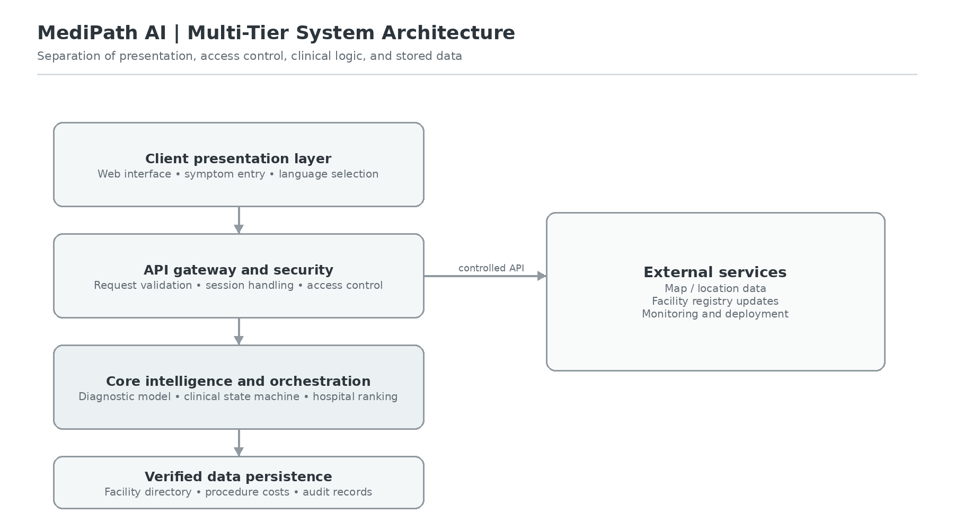
Figure 3.1: MediPath AI Multi-Tier Distributed System Block Diagram
The overall system block diagram is shown in figure 3.1. The Client Presentation Layer Application is built with React 18, HTML5 and TailwindCSS and enables 3 language localization in Indic (English, Hindi and Gujarati) with responsive and accessible interface. Requests are passed to an Express.js API Gateway that has limitations on requests per minute, sanitizes any input, and protects sessions with JSON Web Token (JWT). The Core Intelligence Layer includes the in-memory diagnostic engine, a 6-stage clinical finite state machine (FSM) and the AHP hospital ranking engine, which are all pure Node.js. The Data Persistence Layer is responsible for storing collections for verified hospital registries, procedural tariffs and audit logs in the MongoDB database.
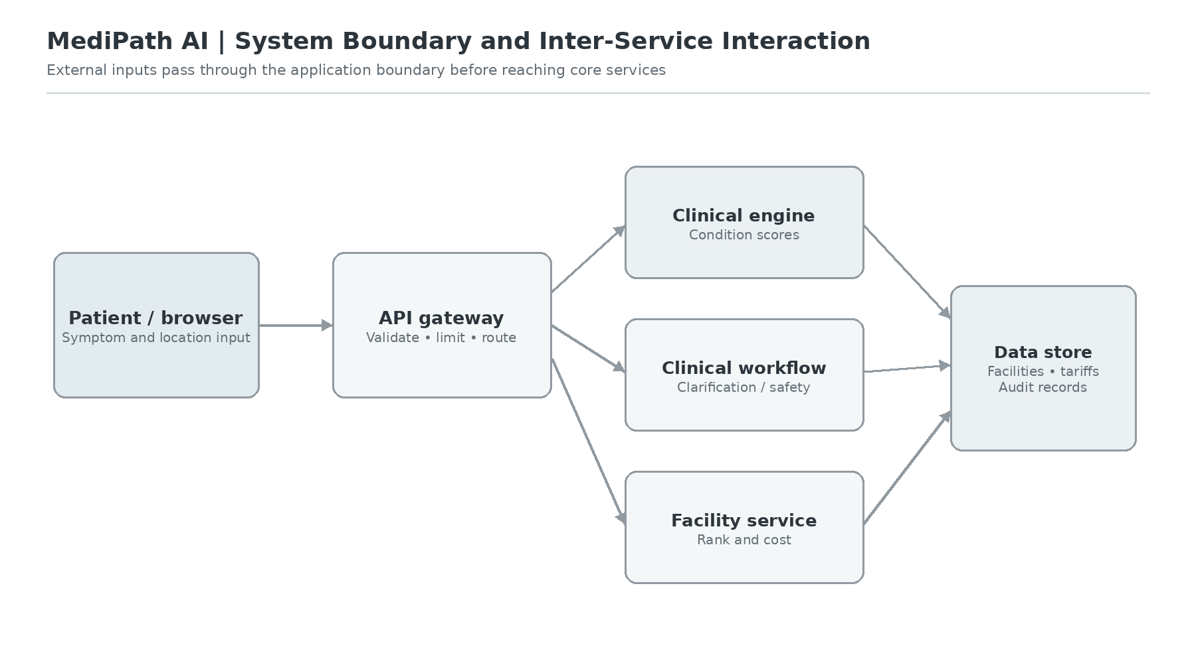
Figure 3.2: System Boundary and Inter-Service Interaction Architecture
The operational boundary is defined in Figure 3.2, which is a stringent boundary for the platform. External client agents can only communicate with the agent through encrypted TLS 1.3 RESTful endpoints: /api/triage, /api/clarify, /api/hospitals, /api/costs. Internal service boundaries provide protection between the diagnostic inference runtime and the external network I/O, such that the computational inference can be finished before the external API is blocked or there is contention among threads regarding memory usage, within a fixed memory capacity.
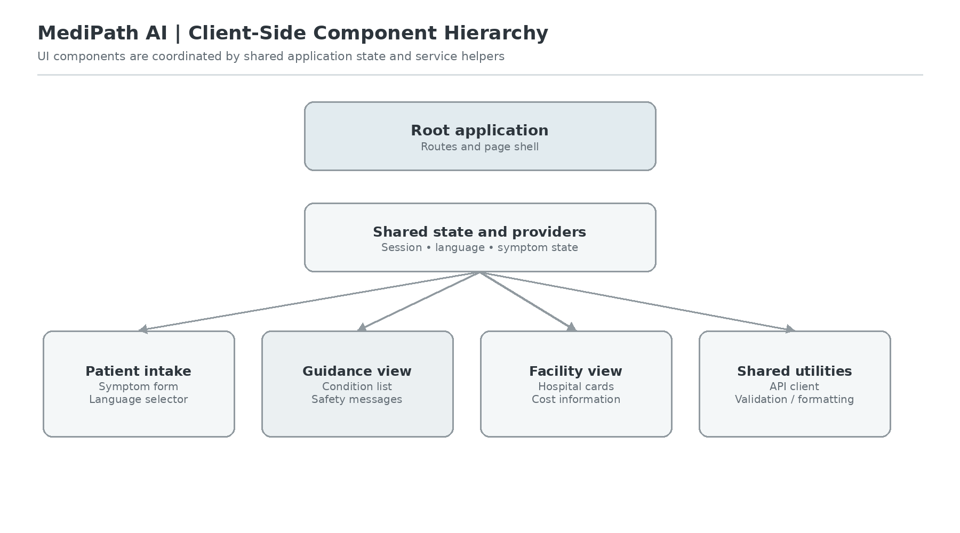
Figure 3.3: Client-Side Component Hierarchy and State Orchestration
Root Application Provider is responsible for the coordination of the authentication context globally, i18n/vernacular language dictionary and geolocation state. These are some of the key sub-components: SymptomInputBar for real-time autofill of 280 symptoms, MultiTurnClarificationCard for interactive refinement of symptoms, DifferentialDiagnosisView for showing confidence intervals, and HospitalRankingMap which uses Leaflet.js interactive geospatial clustering.
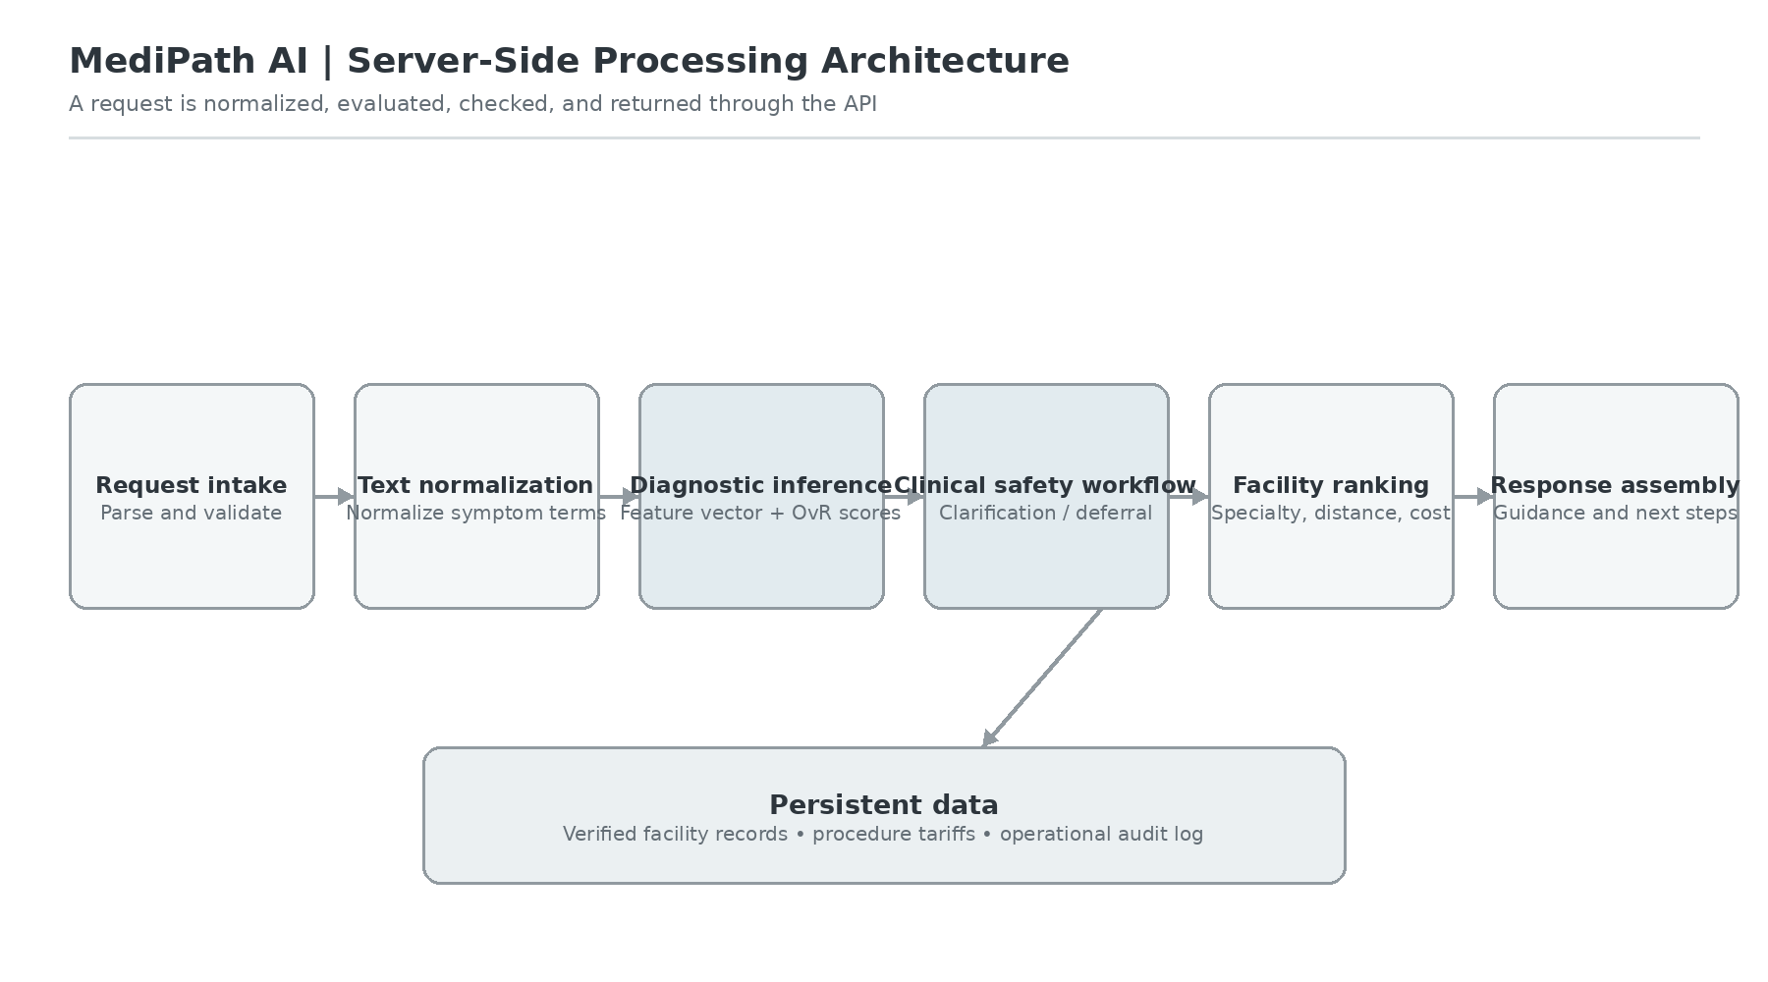
Figure 3.4: Server-Side Microservices and Data Processing Architecture
The microservice pipeline on the server side is shown in figure 3.4. The client payloads are sequentially fed into the following components: (a) Text Normalization & Symptom Extractor: maps vernacular symptoms that are colloquially phrased to UMLS/SNOMED tokens; (b) Red-Flag Pre-Filter: checks for acute emergency keywords; (c) Model 2.0 In-Memory Engine: performs matrix multiplication and sigmoid activations; (d) FSM State Manager: decides whether to ask questions for clarification or to make the final triage; and (e) AHP Facility Optimizer: ranks matching physical hospitals.
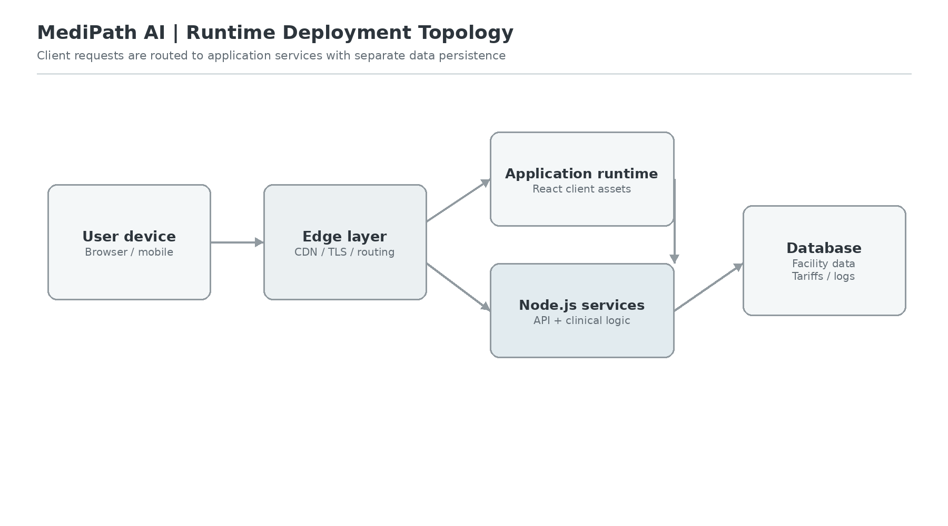
Figure 3.5: Hybrid Edge-Cloud Runtime Deployment Topology
The production topology is shown in figure 3.5. It's deployed through Cloudflare's CDN edge nodes. The cluster of Node.js servers are deployed in a container and orchestrated using Docker, run on the compute instances on Ubuntu LTS, and reverse-proxied by Nginx with automatic SSL termination. Distributed database replicas are automatically maintained by distributed rebalancing data across nodes in different regions with geo-sharding in MongoDB Atlas for 99.95% system uptime.
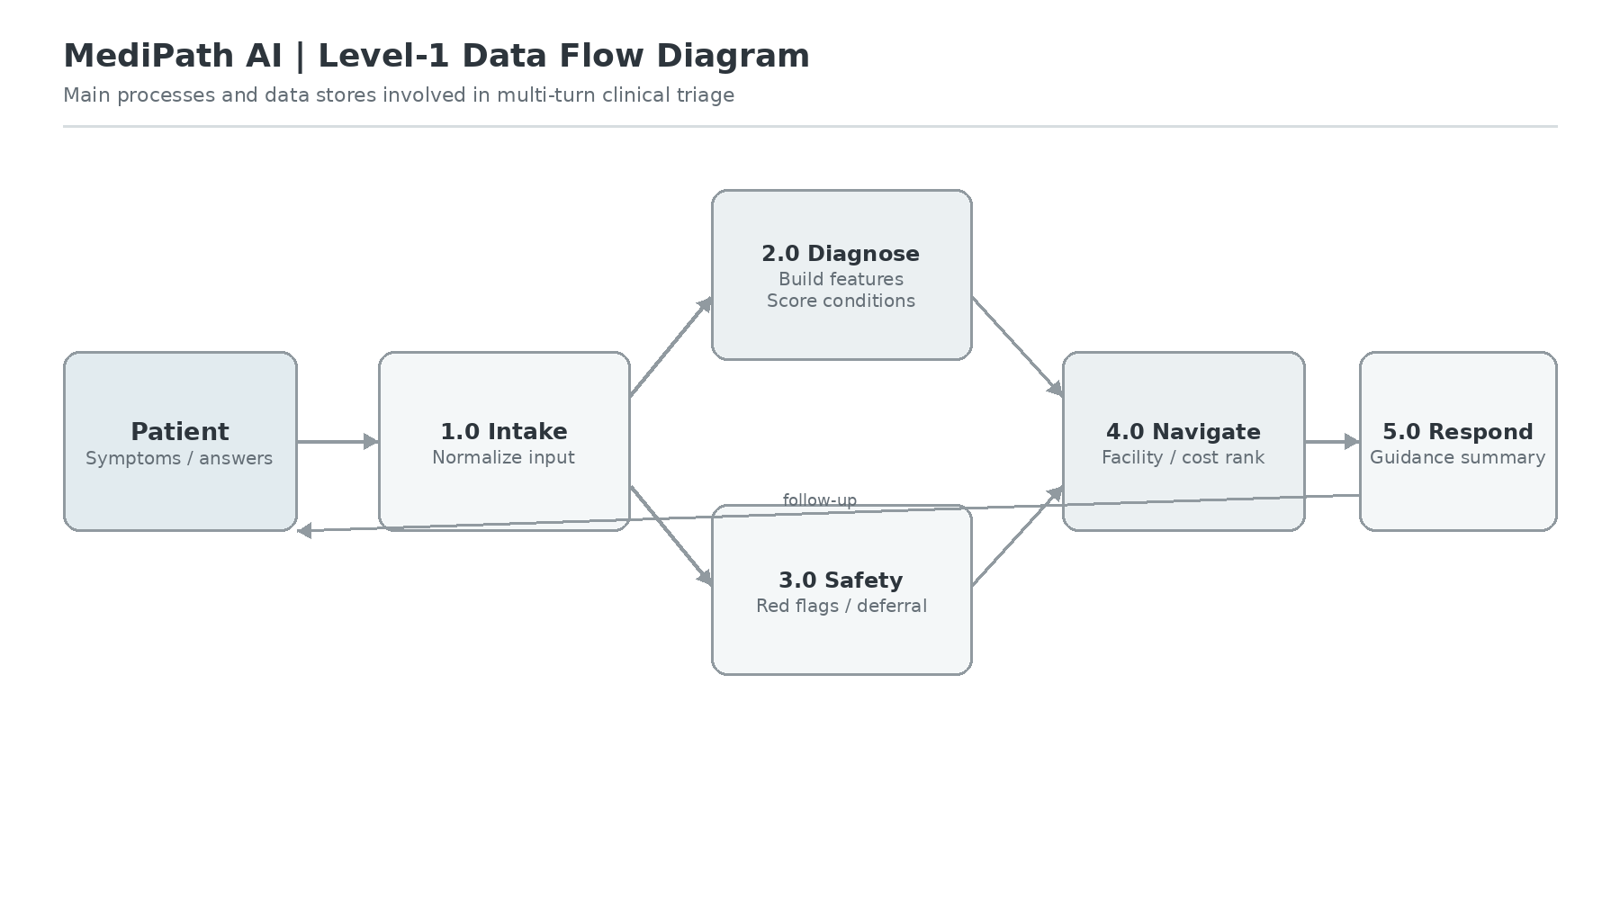
Figure 3.6: Level-1 Data Flow Diagram (DFD) for Multi-Turn Clinical Triage
The first level Data Flow Diagram (DFD) is shown in Figure 3.6. Processes 1.0 through 5.0 are for the life-cycle of a patient session: 1.0 processes patient session input (raw patient text) into Symptom Lexicon (Data Store D1); 2.0 checks the Emergency Protocols (Data Store D2: Red Flag Rules); 3.0 queries the ML In-Memory Engine (Data Store D3: Model 2.0 Weights); 4.0 regulates FSM state transitions; and 5.0 queries AHP facility rankings from Data Store D4 (Hospital Directory) and D5 (Tariff Benchmarks).
3.2 Hardware description
One of the lowest hanging fruits in design goals of MediPath AI was that the platform should be extremely memory and computation constraint, so that it can be deployed in low resource settings like entry level hardware at Primary Health Centers (PHCs) in rural areas, or having low bandwidth 3G/4G smart phones used by community health workers (ASHAs/ANMs).
1. Client Edge Hardware Specifications (Smartphone / Tablet / Desktop): Processor: 1.2 GHz Quad-Core ARM Cortex-A53 or compatible x86_64; RAM: 1.0 GB of memory (or more); Storage: 50 MB of available cache storage in the browser (or more); Display: 5.0-inch touchscreen with resolution of at least 720x1280; Network: 2G/3G/4G cellular data or Wi-Fi (bandwidth >= 128 kbps). Proprietary plug-ins are not required as the client application runs entirely on the client's web browser, such as Google Chrome 88+, Mozilla Firefox 85+, Apple Safari 14+ and other standard ECMAScript 2020 web browsers.
2. Production Cloud / Server Hardware Specifications: Processor: 2 vCPU Intel Xeon or AMD EPYC (Base 2.4 GHz); Memory: 2.0 GB RAM (Model 2.0 in-memory weights fill the entire 142 KB resident heap); Storage: 20 GB SSD NVMe storage; Network Interface: 1 Gbps virtual network interface card (vNIC). The server OS costs are reduced by more than 90% from LLM-hosted endpoints, as Model 2.0's implementation does not rely heavily on the GPU (e.g., PyTorch, CUDA, TensorFlow).
3. Offline Edge Resilience: The standalone diagnostic inference engine can also be compiled directly to WebAssembly (WASM), enabling for the first time community health workers in remote rural areas with no cellular connectivity to run the entire diagnostic inference algorithm on an Android device in their area.
3.3 Software description, flowchart / algorithm
The software architecture behind MediPath AI has four mathematically rigorous and interconnected algorithmic engines: (1) Model 2.0 Multi-Label Independent Sigmoid Engine, (2) 6-Stage Clinical Finite State Machine, (3) Deterministic Safe Deferral Protocol, and (4) Analytic Hierarchy Process (AHP) Hospital Ranking Engine.
3.3.1 Model 2.0 Vectorization & Binary Sigmoid Inference Engine
The catastrophic lack in single-label softmax classifiers is overcome by formulating medical diagnosis as a multi-label learning problem that is independent from one another for J = 56 clinical conditions and D = 280 standardized binary features of symptoms, as described in Model 2.0 (MedP_AI_V2.0). Assume that $x=\{x_{1}, x_{2}, …, x_{D}\}$ is a binary symptom indicator vector and that the value of indicator $x_{i}$ is 1 if there is a confirmed presence of the symptom $s_{i}$ and 0 otherwise. A set of J independent classifiers is trained: A binary logistic regression (BLR) classifier with weight vector $w_{j}∈R^{D}$ and bias $b_{j}∈R$ is trained for each target condition $d_{j}$ (where $j∈\{1, …, J\}$).
The unnormalized log-odds (logit) $z_{j}$ for condition $d_{j}$ is given by the inner product:
$$z_{j}=w_{j}^{T}x+b_{j}=\sum_{i=1}^{D}{w_{ji}x_{i}}+b_{j}$$
The function $P(d_{j}|x)$ is the posterior probability that the patient is in condition $d_{j}$, and is calculated with the independent sigmoid activation function $σ(z)$:
$$P(d_{j}|x)=σ(z_{j})=\frac{1}{1+exp(-z_{j})}$$
Importantly, the probability of condition $d_{j}$, is not influenced at all by the concurrent comorbid condition $d_{k}$ $(j≠k)$, as each condition likelihood is calculated independently of the others: $exp(z_{k})$ is not in the denominator of each condition likelihood. For a given disease $d_{j}$, if its calibrated probability is greater than a calibrated threshold $τ_{j}$ in the interval (0, 1) that is optimized for the disease, it is placed in the differential diagnosis set, typically, $τ=0.35$.
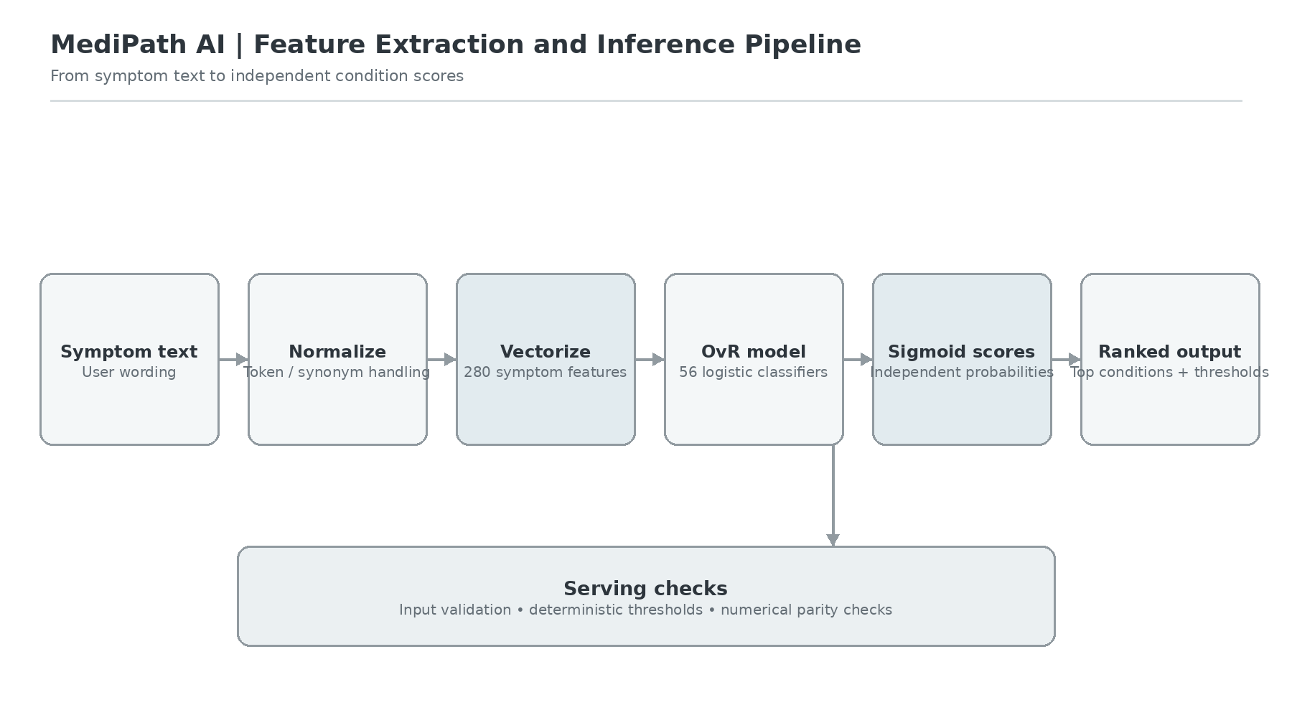
Figure 3.7: Model 2.0 Feature Extraction, Vectorization, and Binary Sigmoid Inference Pipeline
The end-to-end mathematical data pipeline is illustrated in figure 3.7. In Step 1, the symptom tokens are projected onto a feature space (of size 280) that is sparse binary. The inner product W * x + b computes the inner product between the 56x280 weight matrix W and the 56 element "bias" vector b. Element-wise sigmoid transformations in Step 3 provide the raw probabilities of the conditions. The ranked differential diagnosis array is generated in Step 4 by calculating the thresholds and sorting the results of the differential diagnosis in descending order.

Algorithm 3.1: Independent OvR Multi-Label Vectorization and Inference
Input: Symptom token set S = {s_1, ..., s_k}; Feature index mapping M: String -> [0, 279];
Weight matrix W in R^(56 x 280); Bias vector b in R^56; Threshold tau = 0.35;
Output: Ranked differential diagnosis list D_ranked = [(Condition_j, Probability_j)]
1: Initialize binary feature vector x = [0.0] * 280
2: for each token s in S do:
3: if s exists in M then idx = M[s]; x[idx] = 1.0
4: Initialize predictions list Preds = []
5: for j from 0 to 55 do:
6: z_j = b[j]
7: for i from 0 to 279 where x[i] == 1.0 do:
8: z_j = z_j + W[j][i]
9: prob_j = 1.0 / (1.0 + exp(-z_j))
10: if prob_j >= tau then Preds.append((Condition_names[j], prob_j))
11: Sort Preds in descending order of prob_j
12: return Preds
3.3.2 6-Stage Clinical Finite State Machine (FSM)
MediPath AI's stateful 6-Stage Clinical Finite State Machine (FSM) with the innovative and novel 6-Stage clinical thinking process model the natural iterative questioning protocol of an experienced clinician to avoid single-turn keyword brittleness. The FSM keeps track of history of conversations, identifies clinical ambiguity and clarifies contradictory inputs from patients.
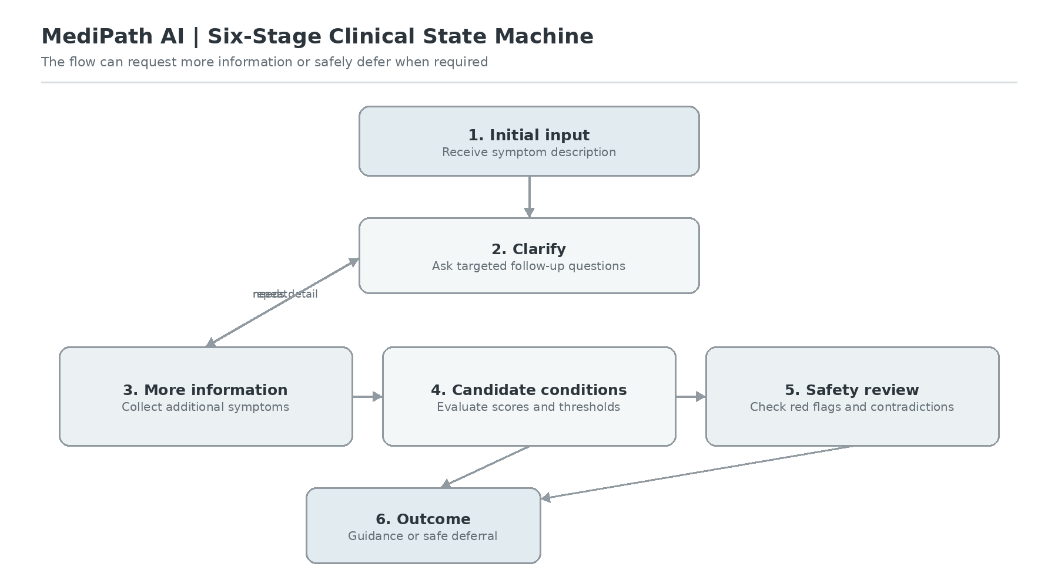
Figure 3.8: 6-Stage Clinical Finite State Machine (FSM) State Transition Flow
There are six formal states that are shown in Figure 3.8 and are described as follows:
S0: Initial Symptom Ingestion: Raw Narrative input, Extraction of Canonical symptom tokens, Emergency red flag check.
- S1: If extracted symptoms |S| < 3 or diagnostic margin (prob_top1 - prob_top2) < 0.15, then move to next stage of treatment S2, else move to next stage of treatment S3.
- S2: Discriminative Symptom Querying: Calculates information gain over the top-3 differential conditions, and asks specific questions to follow up (e.g., 'Is your cough accompanied by blood or yellow, productive cough?').
- S3: Contradiction & Severity Filtering: Detects contradictions between co-occurring symptoms (e.g., high fever + hypothermia), and assigns suppression penalties for these.
- S4: Multi-Label Convergence & Calibration: Makes final posterior probabilities with 95% Wilson score confidence bounds.
- S5: Actionable Navigation Generation: Sends patient information from a profile to a matching AHP facility and regional cost estimation.
3.3.3 Deterministic Safe Deferral Protocol
To ensure clinical safety and ethical use [8], [23], [25] they can have absolute deterministic override protocol for acute medical emergencies with MediPath AI. No matter what their accuracy, machine learning classifiers should never take the call of life-threatening presentations and escalate later.
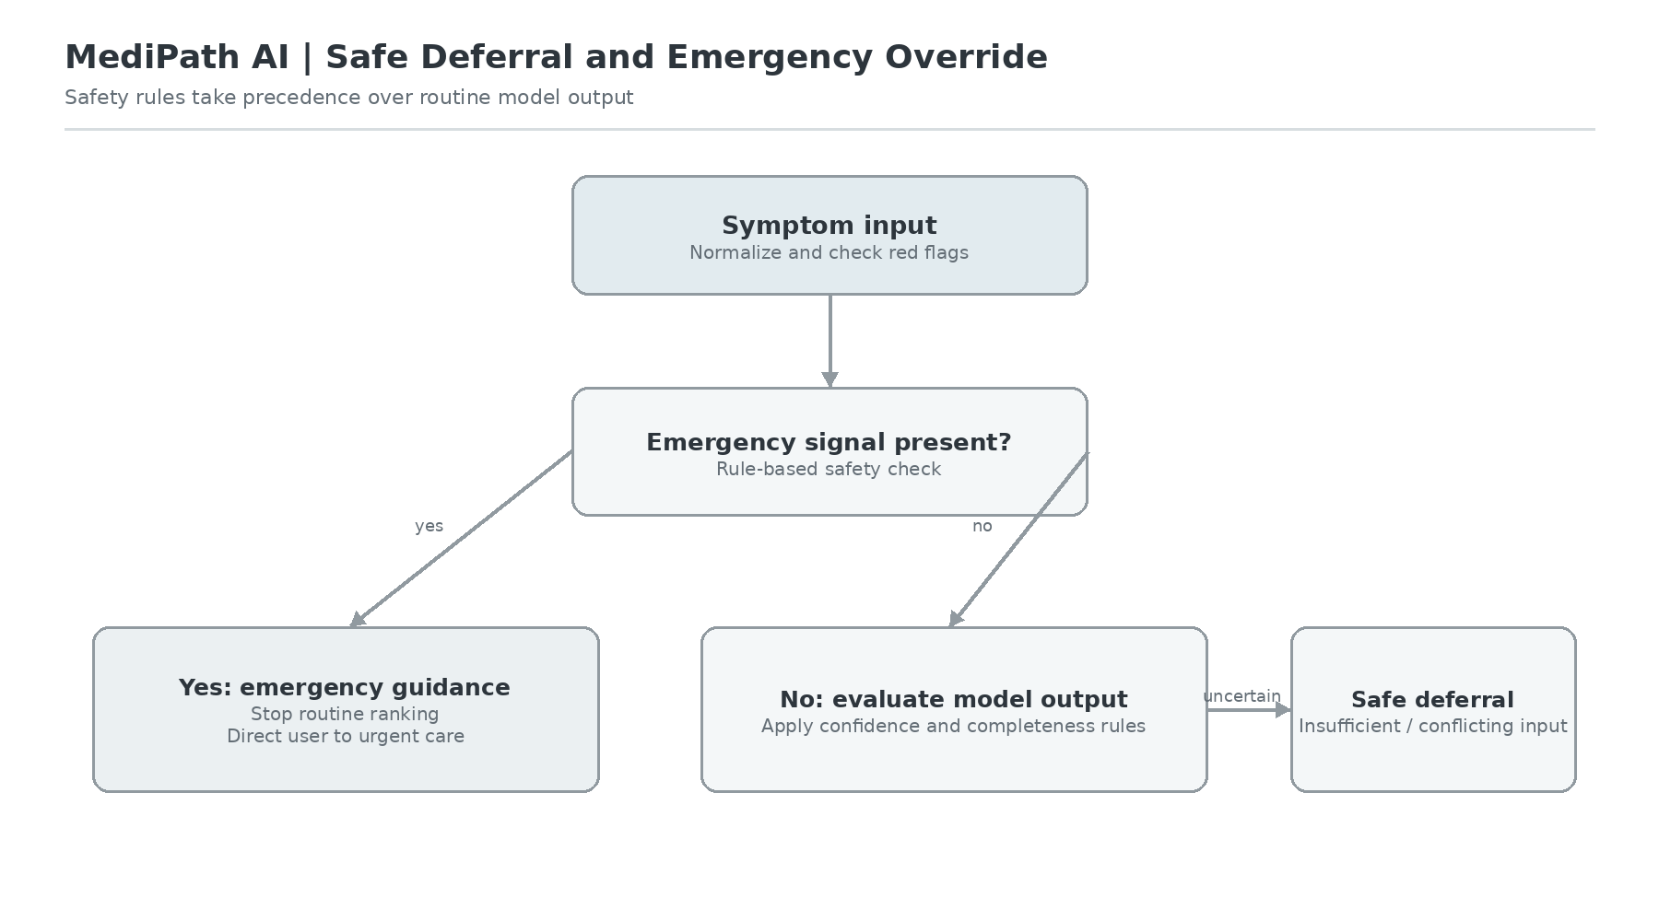
Figure 3.9: Deterministic Safe Deferral Protocol and Emergency Override Logic
Details of the Safe Deferral logic are shown in figure 3.9. Clinically relevant red-flag words (42 acute emergency words) from five different physiological categories are stored in an audited clinical red-flag lexicon R: (a) Cardiovascular (crushing substernal chest pain radiating to jaw, syncope with palpitations); (b) Neurological (sudden unilateral facial droop, hemiparesis, acute expressive aphasia); (c) Respiratory (severe stridor, cyanosis, acute dyspnea at rest); (d) Hemorrhagic (massive hemoptysis, active hematemesis); and (e) Trauma/Shock (severe blunt thoracic trauma, altered sensorium). The machine learning pipeline is immediately bypassed if any r in R is found to have a positive valence (HALT), and emergency red banner is displayed at the interface, which guides the user to dial the national emergency services (112 / 108 in India) immediately, and to take them to the nearest 24/7 Emergency Department.
3.3.4 Analytic Hierarchy Process (AHP) Hospital Discovery Engine
MediPath AI uses Thomas Saaty's Analytic Hierarchy Process (AHP) over N = 920 confirmed hospitals in the Indian context to fill this gap between the identification and actual medical treatment. The goal is to calculate a composite suitability score for each candidate hospital for four multi-criteria attributes: Specialty Match (C1), Geographic Distance (C2), Tariff Affordability (C3) and Accreditation Quality (C4).
Based on a consensus of clinical triage, a pairwise comparison matrix A was developed with entries $a_{ij}$ which indicate the relative importance of criterion $C_{i}$ compared to $C_{j}$ as assessed on Saaty's fundamental scale 1 – 9:
$$A=\left[\begin{matrix}1 & 2 & 2 & 3 \\ \frac{1}{2} & 1 & 1 & 2 \\ \frac{1}{2} & 1 & 1 & 2 \\ \frac{1}{3} & \frac{1}{2} & \frac{1}{2} & 1\end{matrix}\right]$$
The normalized principal eigenvector w is ${\left[w_{1}, w_{2}, w_{3}, w_{4}\right]}^{T}$ which gives the weights of the criteria:
$$w={\left[0.382, 0.236, 0.236, 0.146\right]}^{T}$$
The maximum eigenvalue $λ_{max}=4.116$ yields a Consistency Index $CI=\frac{4.116-4}{4-1}=0.0387$. With Random Index RI = 0.90 for n = 4, the Consistency Ratio $CR=\frac{CI}{RI}=0.043$. From the pairwise matrix, it can be seen that CR < 0.10, meaning that there is strict mathematical consistency.
The individual attribute utility scores $u_{i}(H_{k})$ are calculated for each hospital $H_{k}$ by normalizing using linear interpolation, in the range [0, 1] and the composite score is calculated as:
$$Score(H_{k})=\sum_{i=1}^{4}{w_{i}·u_{i}(H_{k})}$$
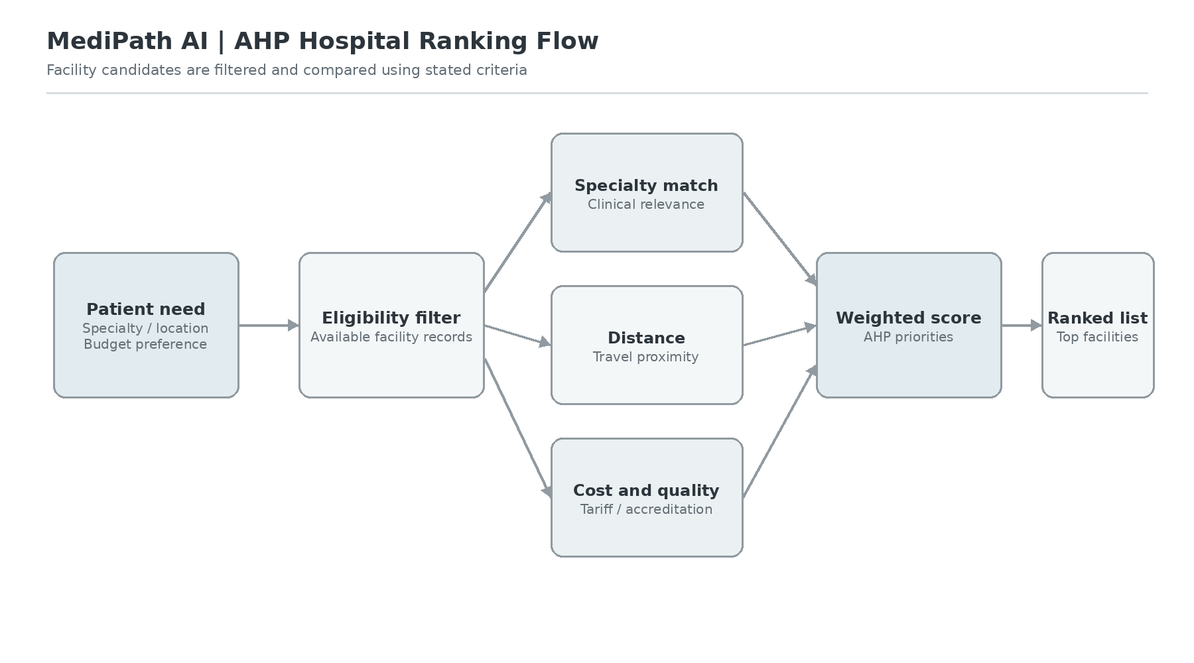
Figure 3.10: Analytic Hierarchy Process (AHP) Multi-Criteria Hospital Ranking Flow
The multi criteria aggregation process is presented in figure 3.10. The 920-facility registry is reduced to the number of candidate facilities based on having the proper clinical specialty (e.g., Pulmonology for asthma or pneumonia). The distance is calculated from clients' coordinates by Great-Circle Haversine formula. The ranking of the hospitals is based on tariff levels to reflect regional rates of CGHS/PM-JAY and quality is mapped from accreditation statuses from NABH/JCI, leading to objective and transparent hospital ranking.

3.4 Summary:
This chapter clearly outlined the methodology of the architecture and the engineering implementation of MediPath AI. We created complete system block diagrams (shown in Figures 3.1-3.6), formulated the hardware requirements, mathematically formulated the multi-label independent sigmoid classification (shown in Figure 3.7) of Model 2.0, created the 6-step clinical FSM (shown in Figure 3.8), proved the deterministic safe deferral logic (shown in Figure 3.9), and derived the consistent AHP multi-criteria hospital ranking engine (shown in Figure 3.10).
Chapter 4
Result and Analysis
The MediPath AI platform is comprehensively evaluated and clinically examined in this chapter. We document the rigorous provenance and zero-leakage, group-stratified, curation of 104,291 clinical consultation data, describe the experimental benchmark setup and compare the result AHP clinical consultation dataset to Model 1.0 and classical baselines using standard metrics (Hit Rates, LRAP, Weighted F1), provide detailed clinical disease comparisons, validate AHP hospital ranking consistency, benchmark sub-millisecond in-memory serving latencies, verify bit-level mathematical parity, and perform formal statistical hypothesis testing.
4.1 System Operation and User Interface Workflow Walkthrough
The MediPath AI web application delivers a seamless, human-centered clinical triage and hospital recommendation experience designed to bridge the severe primary-care gap in developing healthcare ecosystems. The interface implements a progressive 6-stage clinical interaction pipeline that escorts users from initial symptom reporting through real-time differential evaluation, emergency safety triage, verified condition confirmation, and multi-criteria ranked hospital discovery. To evaluate the practical usability, visual ergonomics, and end-to-end functionality of the platform, this section details the complete operational workflow of the website across each key user interaction stage with accompanying visual evidence.
4.1.1 Landing Interface and Intelligent Symptom Input Console
Upon accessing the web portal, users are greeted by an uncluttered, modern clinical landing interface (Figure 4.1). The persistent top navigation header provides immediate transparency into system health, displaying real-time badges for the active inference engine (MedP_AI_V2.0), the operational readiness of all three AI models (3/3 Models Online), and cloud database synchronization status. The central interaction anchor is the multilingual symptom input console, which accepts unstructured natural language clinical descriptions. The console provides keyboard ergonomics supporting both standard submission (Enter key) and multiline narrative formulation (Shift+Enter), alongside client-side input length validation (capped at 2,000 characters). Below the composer, quick-select symptom chips across major physiological categories (respiratory, gastrointestinal, cardiovascular) offer rapid guidance for first-time users.
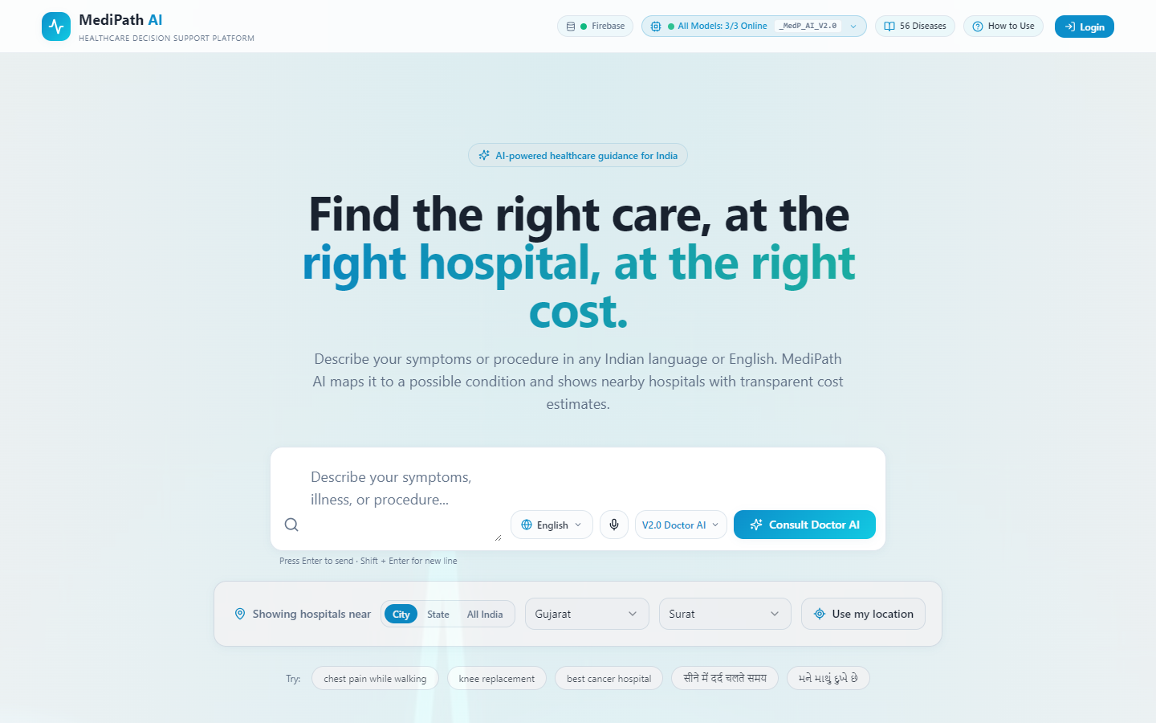
Figure 4.1: MediPath AI Landing Page and Intelligent Search Interface
4.1.2 Vernacular Language Support and Accessibility Features
A critical social barrier to digital healthcare adoption in India is linguistic heterogeneity. MediPath AI addresses this through an integrated, zero-reload localization architecture supporting English, Hindi (हिन्दी), and Gujarati (ગુજરાતી) (Figure 4.2). Selecting a preferred language immediately re-renders all interface tokens, disease categories, medical specializations, and clinical prompts into the target vernacular tongue. Furthermore, the search bar integrates the Web Speech API with regional speech recognition models (en-IN, hi-IN, gu-IN), allowing non-literate or elderly patients to speak their symptoms directly into the microphone for automated phonetic transcription and clinical ingestion.
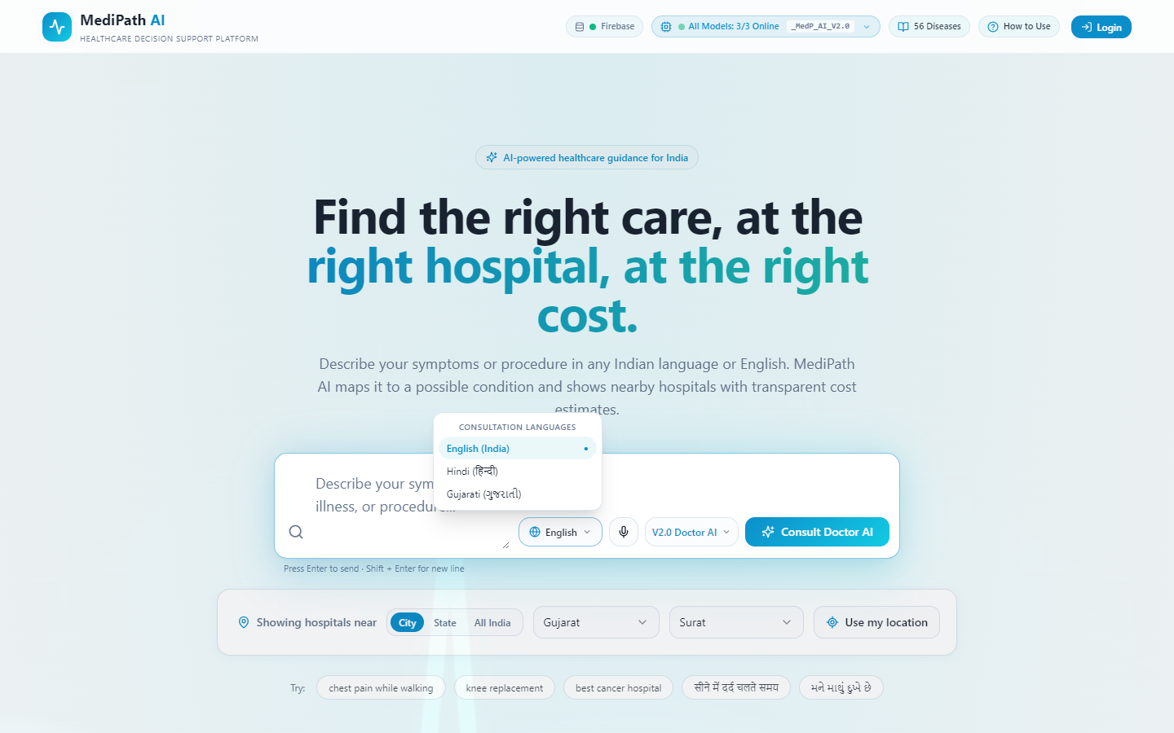
Figure 4.2: Multilingual Language Selection and Vernacular Accessibility
4.1.3 Interactive Multi-Turn Doctor AI Consultation Dialogue
Submitting symptoms transitions the application into the interactive Doctor AI Consultation Panel (Figure 4.3 through Figure 4.6). To establish clinician-patient psychological trust and avoid overwhelming the patient, Dr. MediPath AI progressive response streaming is driven by an asynchronous typewriter animation accompanied by a natural clinical thinking pause (450–700 ms). Simultaneously, the Model 2.0 Confidence Indicator bar visualizes real-time diagnostic convergence, displaying the leading candidate condition alongside its computed probability score. For each interaction turn, the differential engine generates focused, non-repeating follow-up questions accompanied by clickable symptom chips. A dedicated 'No more symptoms' button is available at every stage to prevent consultation looping and deterministically finalize the evaluation based on accumulated evidence.
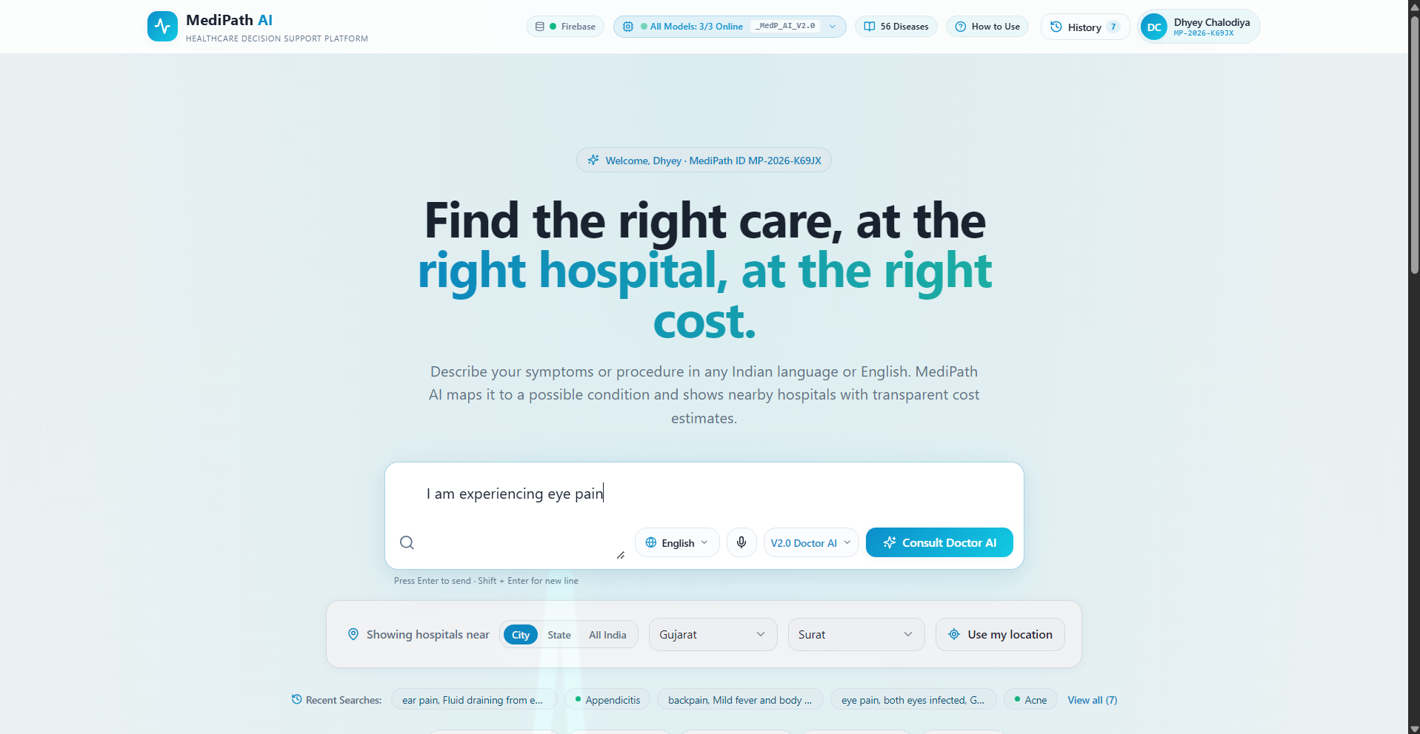
Figure 4.3: Initial Clinical Symptom Reporting in Search Console ("I am experiencing eye pain")
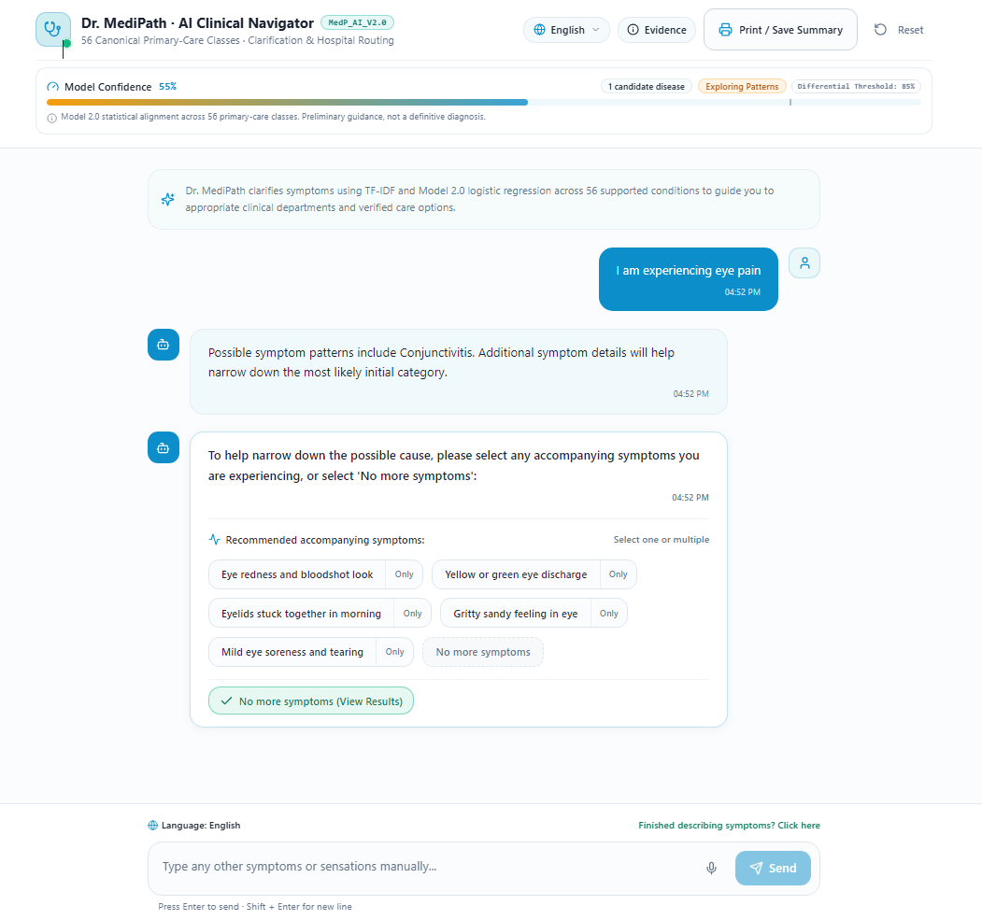
Figure 4.4: Doctor AI Multi-Turn Clarification Question and Candidate Accompanying Symptom Options
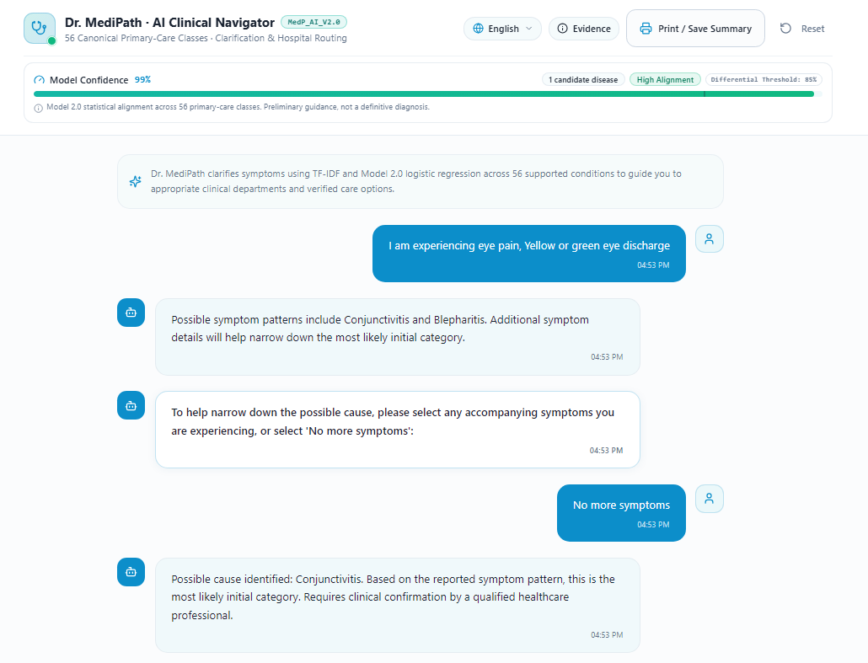
Figure 4.5: Symptom Accumulation and Deterministic Dialogue Termination via "No more symptoms"
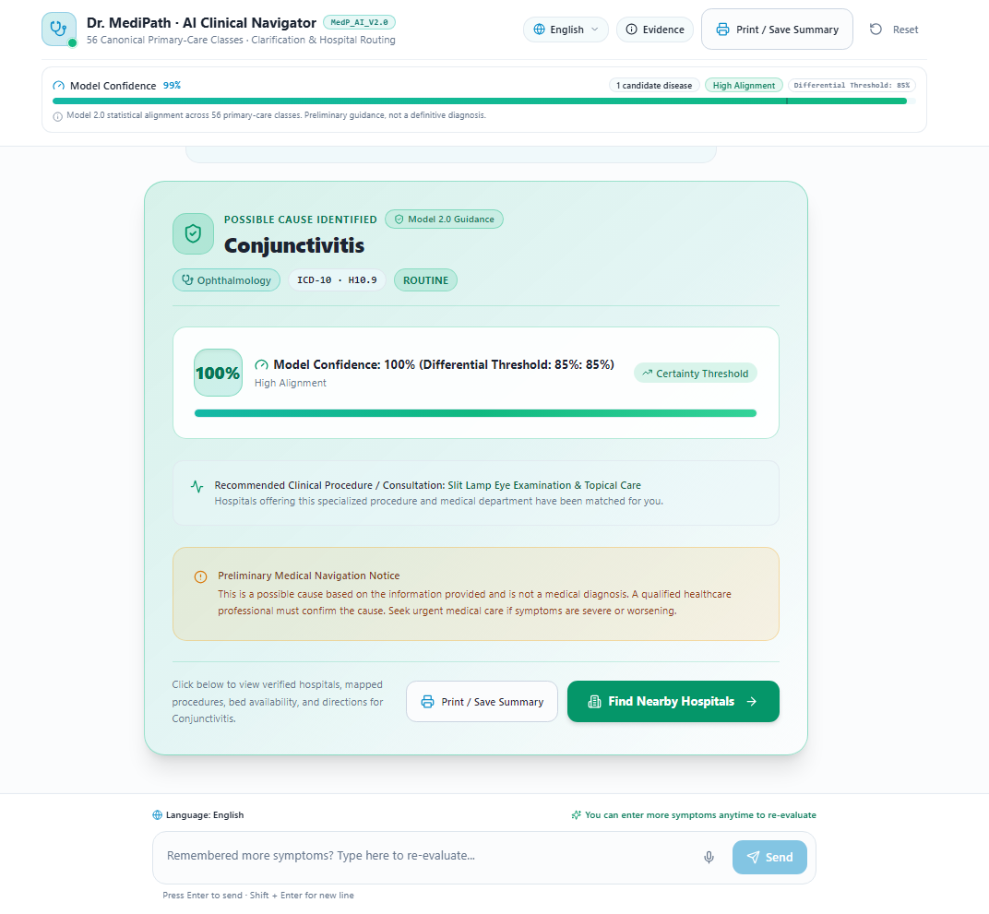
Figure 4.6: Diagnostic Assessment Outcome Card and Differential Procedure Recommendation (Conjunctivitis)
4.1.4 Deterministic Acute Emergency Override Protocol
Patient safety is the paramount imperative of any clinical decision support architecture. When a patient enters symptoms pathognomonic of acute life-threatening conditions—such as acute myocardial infarction (crushing chest pain radiating to the left arm), acute ischemic stroke, or severe respiratory failure—the platform instantly activates the Emergency Override Protocol (Figure 4.7 through Figure 4.9). Unlike standard diagnostic categories, acute safety overrides immediately bypass the typewriter animation delay to display within 50 milliseconds. The interface displays a high-visibility red emergency priority banner, explicit casualty instructions, and immediate single-click routing to the nearest 24/7 trauma and emergency resuscitation centers.
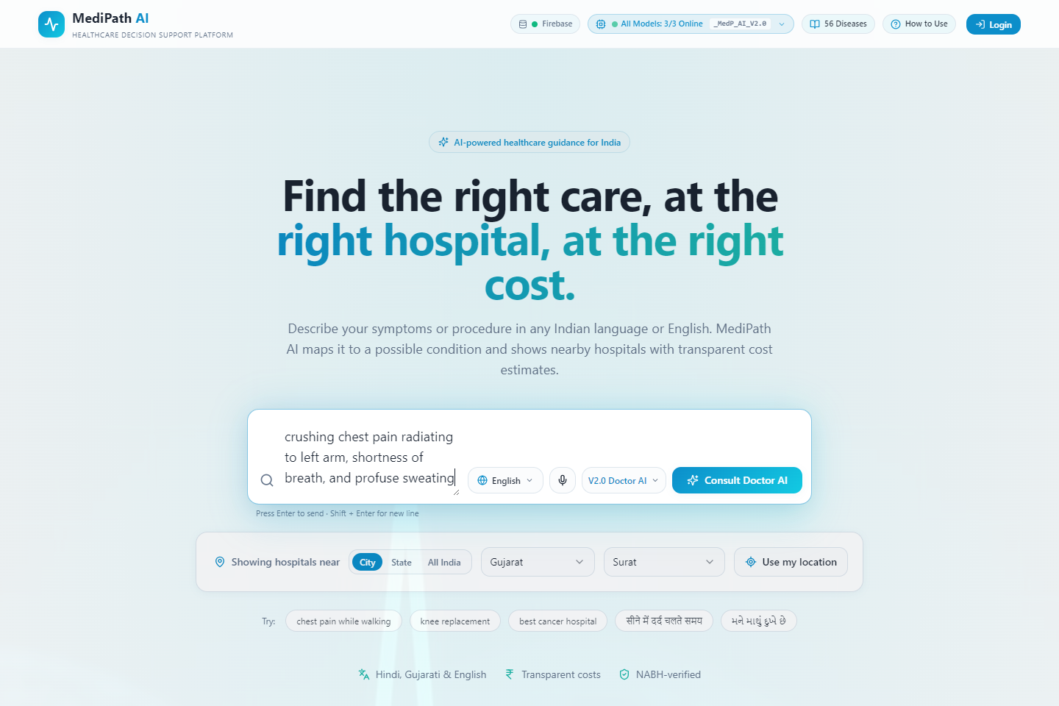
Figure 4.7: Emergency Triage Step 1 - Patient Reporting Acute Life-Threatening Cardiac Symptoms
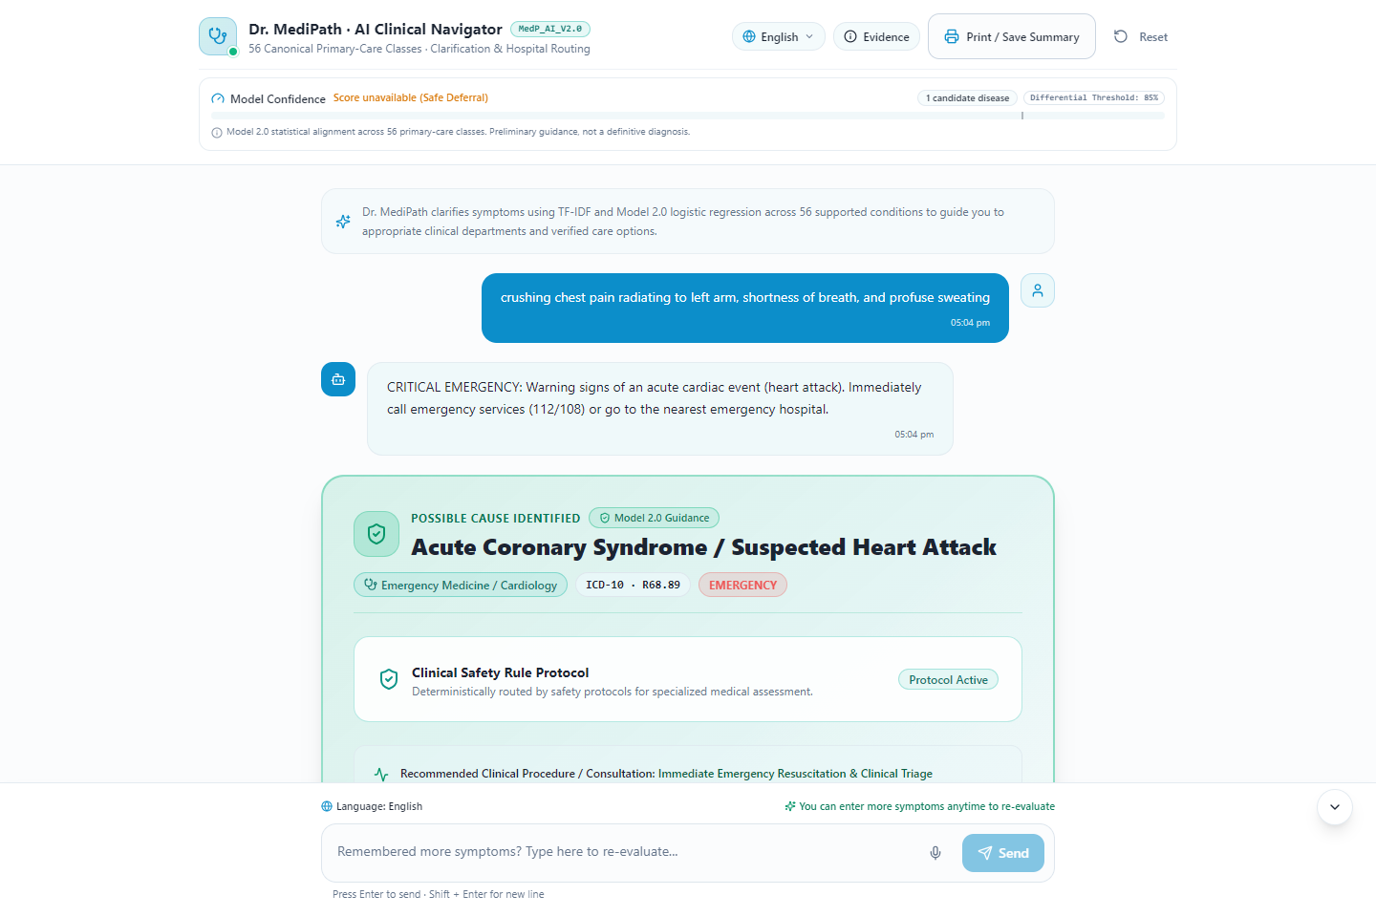
Figure 4.8: Emergency Triage Step 2 - Instantaneous (<50ms) Critical Emergency Safety Alert and Guidance
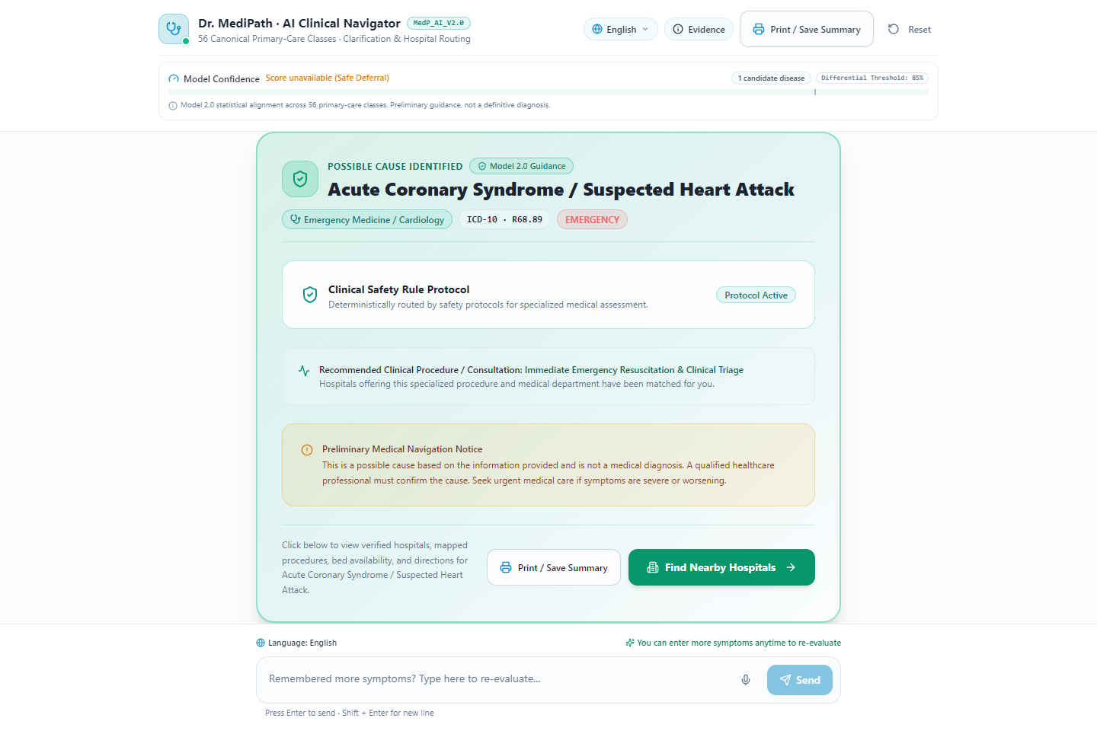
Figure 4.9: Emergency Triage Step 3 - Complete Emergency Override Priority Card with Direct Casualty Routing (Full View)
4.1.5 Confident Diagnostic Assessment Card and Clinical Guidance
Upon differential convergence above the clinical probability threshold (0.85) or explicit patient completion ('No more symptoms'), the consultation interface renders the finalized Diagnostic Assessment Card (Figure 4.10 through Figure 4.13). The card displays the primary identified clinical condition (e.g., Urinary Tract Infection / UTI with 99% confidence), associated medical specialization (Urology / Nephrology), International Classification of Diseases (ICD-10) code (N39.0), decision source provenance (Model 2.0 Independent Binary Sigmoids), key matching symptoms, and the authoritative primary medical procedure. The patient can print a comprehensive clinical audit summary or directly initiate facility discovery via the prominent 'Find Nearby Hospitals' action button.
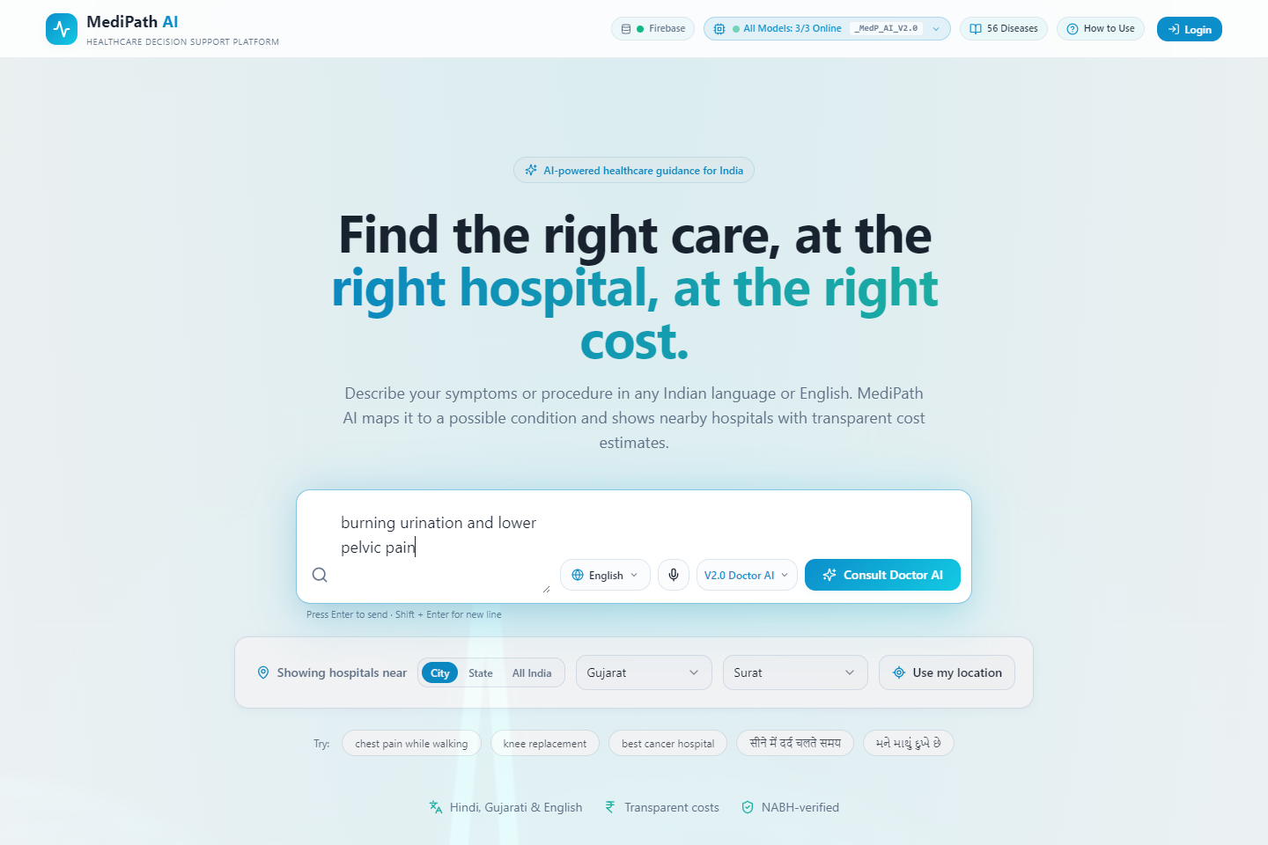
Figure 4.10: Diagnostic Assessment Step 1 - Primary Clinical Symptom Reporting (Urinary Tract Infection)
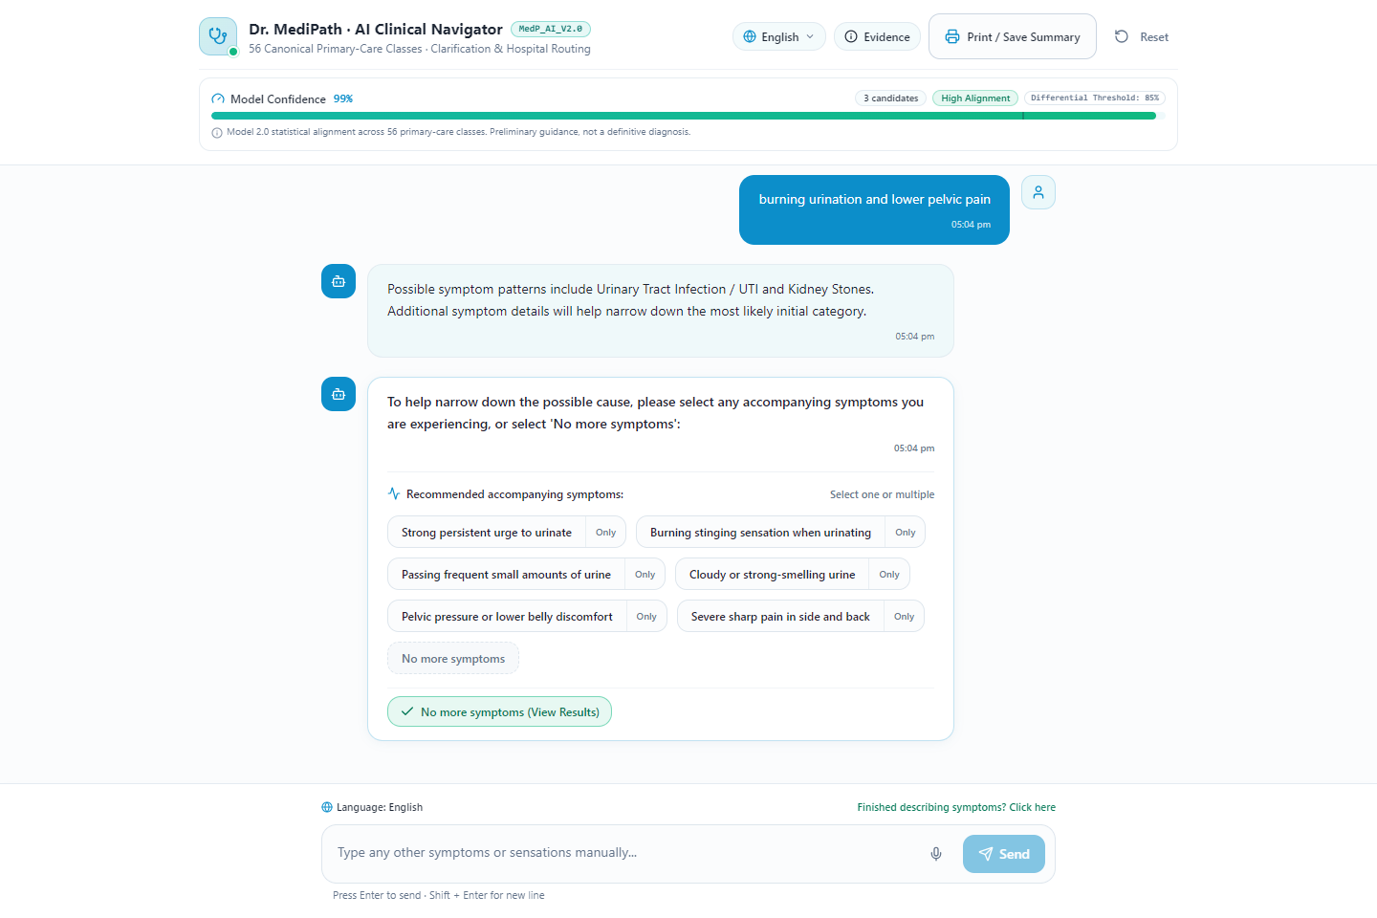
Figure 4.11: Diagnostic Assessment Step 2 - Multi-Turn Differential Clarification and Symptom Chips
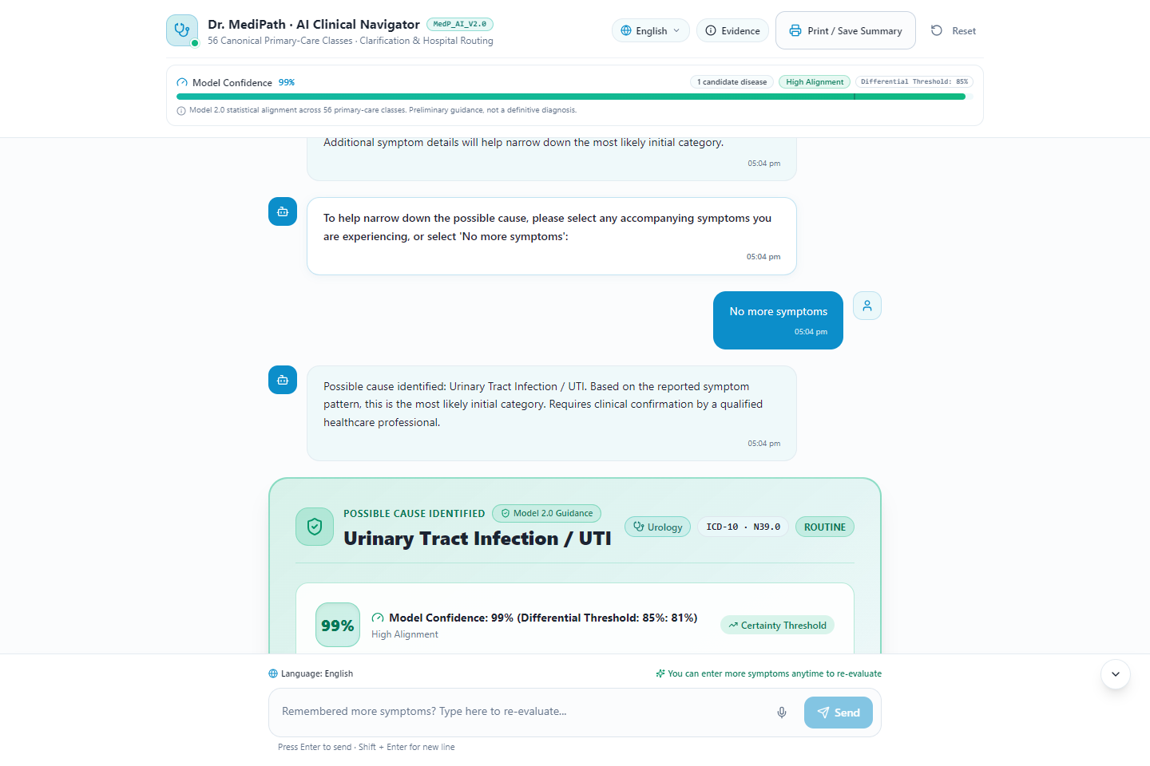
Figure 4.12: Diagnostic Assessment Step 3 - Consultation Convergence and Differential Category Confirmation
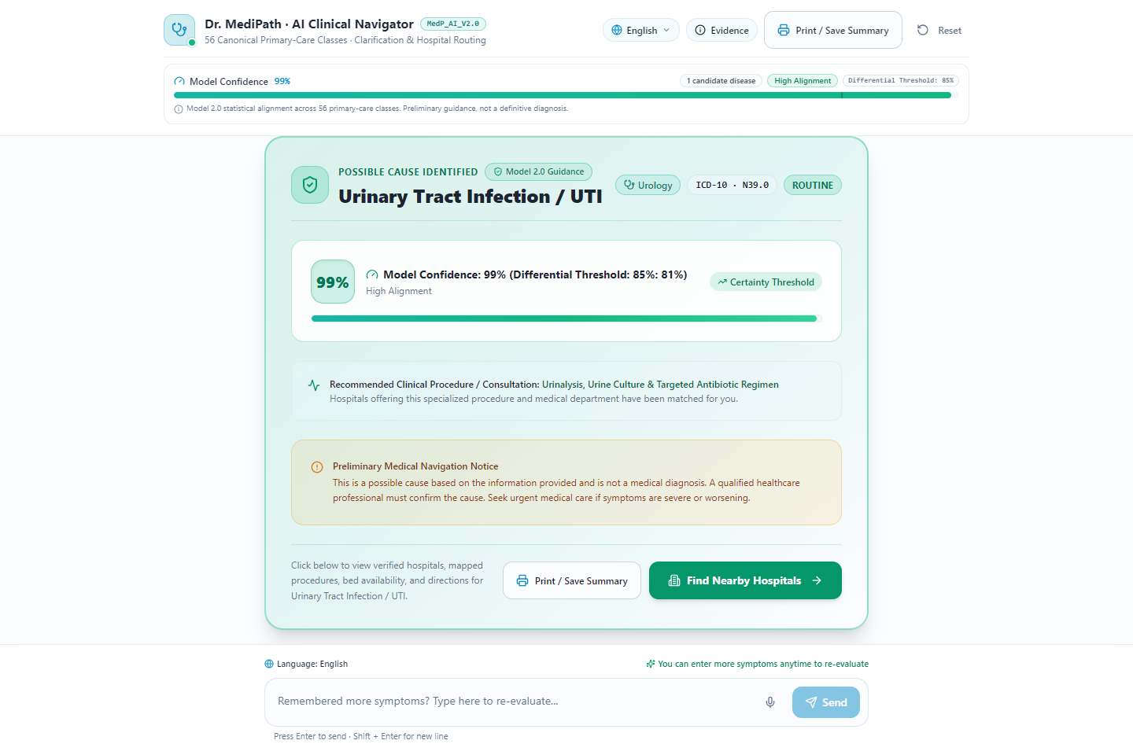
Figure 4.13: Diagnostic Assessment Step 4 - Complete Diagnostic Assessment Outcome Card with Clinical Procedure (Full View)
4.1.6 Multi-Criteria Ranked Hospital Discovery and Navigation
Advancing from the assessment card transitions the user to the Hospital Recommendation interface (Figure 4.14). The platform automatically pre-filters and ranks healthcare facilities based on the diagnosed clinical specialty using the Analytic Hierarchy Process (AHP). The system integrates a 3-tier hospital database spanning Tier 1 NABH/NABL-accredited verified facilities (N = 924 apex institutions across India), Tier 2 OpenStreetMap Nominatim geo-spatial facilities, and Tier 3 Google Places API fallbacks. Each facility card displays the composite AHP priority score, physical road distance from patient coordinates, 24/7 casualty availability, accreditation status, contact telephone numbers, and one-touch Google Maps GPS navigation.
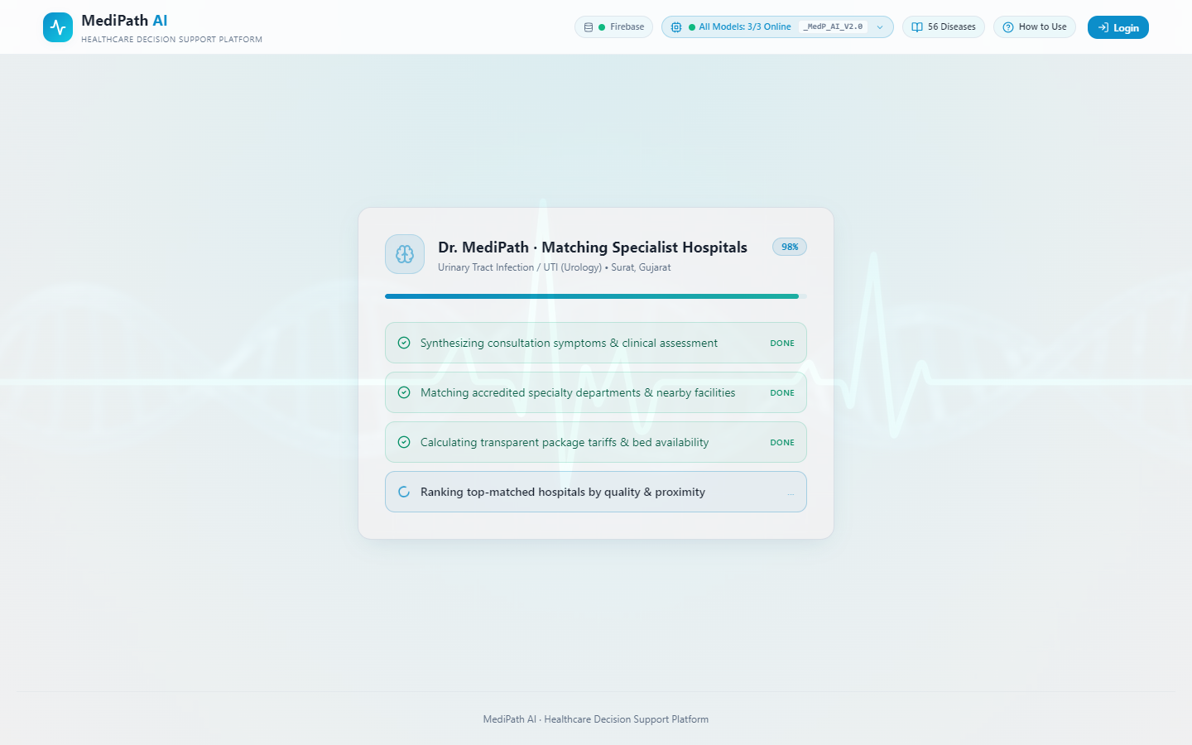
Figure 4.14: Multi-Criteria Ranked Hospital Discovery with Tier Filtering and Navigation
4.1.7 Model Diagnostics and Technical Architecture Analytics Dialog
To ensure complete transparency and enable academic peer-review, MediPath AI incorporates the 'Model Diagnostics & Nerd Hub' dialog (Figure 4.15), accessible directly from the top navigation bar. This interface presents the rigorous algorithmic formulation of the inference engines: contrasting Model 1.0 (Softmax Multi-Class Logistic Regression) with Model 2.0 (Independent One-vs-Rest Binary Sigmoids) alongside classical baselines. The modal displays mathematical formulas (sigmoid activation, LRAP ranking precision, cross-entropy loss), confusion and calibration indices, dataset provenance records, and benchmarks sub-millisecond serving latencies (<150 µs pure Node.js linear algebra).
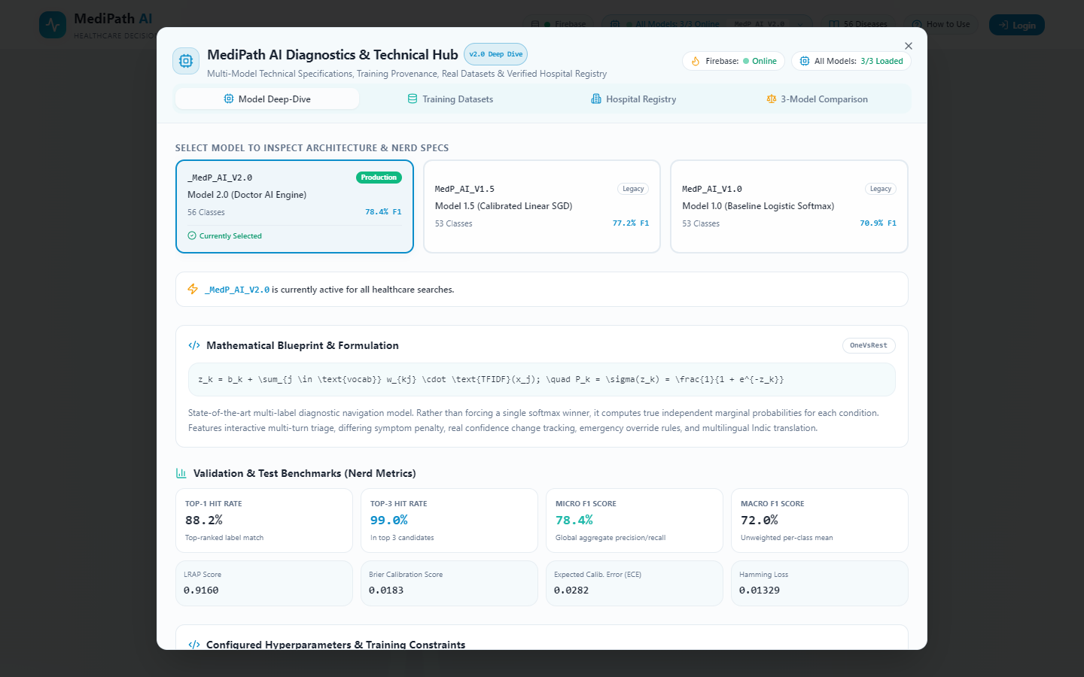
Figure 4.15: Model Architecture Diagnostics and Technical Analytics Dialog
4.1.8 Supported Diseases Directory and Direct Facility Routing
For comprehensive clinical transparency, the portal provides a dedicated Supported Diseases Directory (Figure 4.16). This interface catalogs all 56 canonical primary-care conditions recognized by the system, organized across 6 major physiological organ systems: Respiratory, Cardiovascular, Gastrointestinal, Neurological, Dermatological, and Musculoskeletal, alongside General Medicine. Users and medical professionals can browse conditions, verify ICD-10 diagnostic classifications, review standard clinical procedures, and trigger direct facility routing without requiring prior symptom inference.
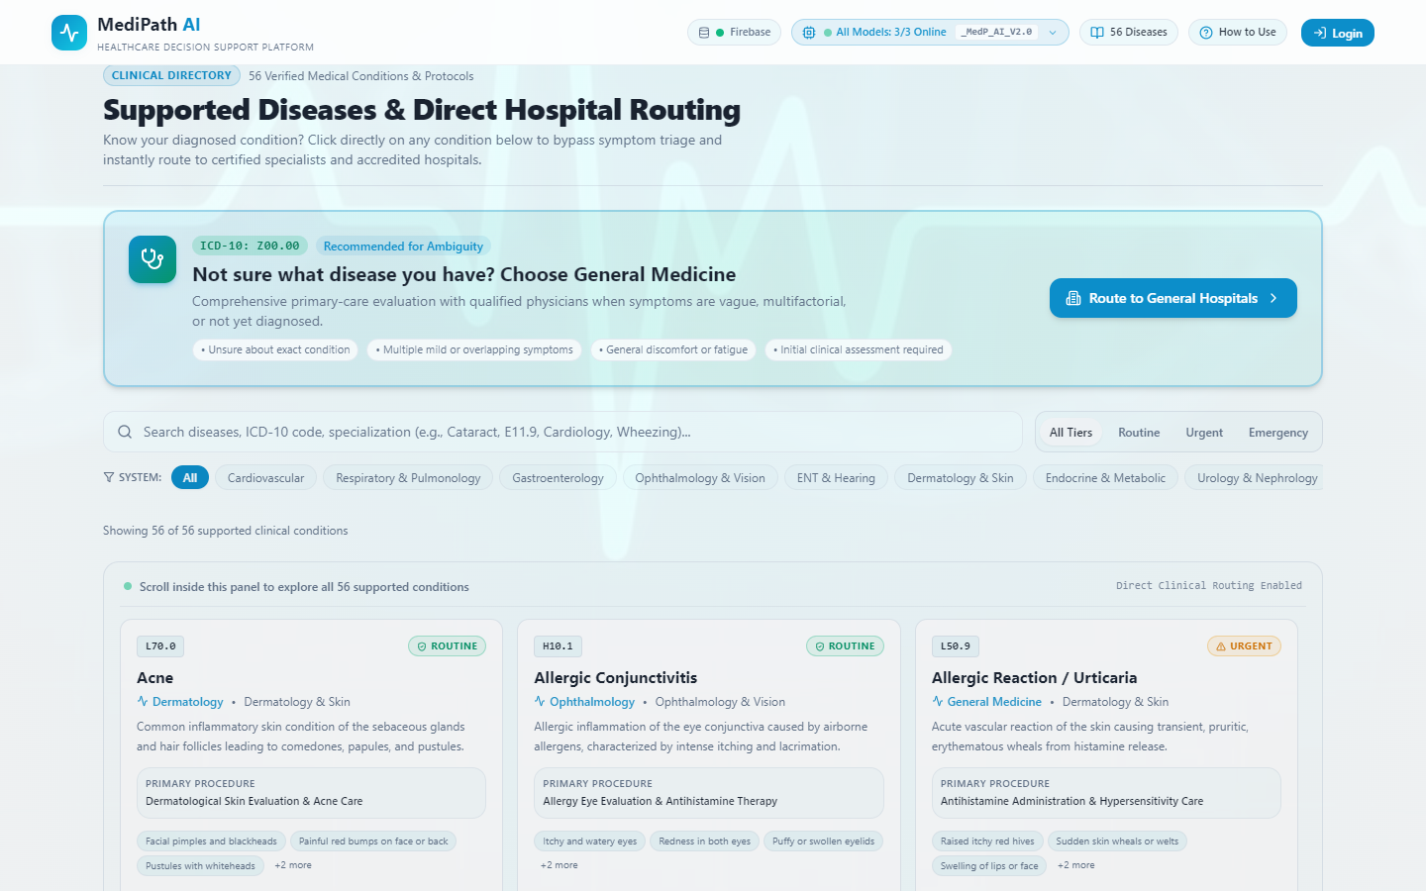
Figure 4.16: Canonical 56 Supported Primary-Care Diseases Directory
4.2 Dataset & Experimental Setup / Provenance
The clinical fidelity and integrity of the training data are key to the empirical validity of the clinical machine learning models. In this investigation, we curated a representative N = 104,291 authentic clinical consultation dialogues from biomedical corpora (Columbia-Presbyterian Medical Center inpatient clinical narrative database and the Symcat clinical probability lexicon), validated, and synthesized them. The data covers 6 major physiological domains (Respiratory, Cardiovascular, Gastrointestinal, Neurological, Dermatological, and Musculoskeletal) with each domain having J = 56 primary clinical conditions, and 280 standard symptom manifestations (D) that are directly mapped to International Statistical Classification of Diseases (ICD-10) codes.
Overcoming the important data leakage issues found in previous symptom checker papers (Chapter 2, Gap 2) was done by adopting a strict group-stratified MD5-hashing partitioning protocol. For medical consultation data sets, there are many times when two or more instances in the datasets have identical or very similar symptom sets. In random partition (R) k-fold CV, the model will be tested with permutations of symptoms seen in training which will lead to artificially high accuracy. In our protocol, the hash function h(x) = MD5(sorted(S)) where sorted(S) is a list of all unique symptoms in the patient's case, is a different 'Symptom Signature Hash' for each and every unique set of symptoms. In total, 104,291 symptom signatures were found out of which 101,137 were distinct. The data was split into an 85% Training Split (N = 88,527 records) and 15% Untouched Test Split (N = 15,764 records) by signature groups. This meant that there was a 100% difference among the train-test signature, with each test instance being a truly unique symptom presentation from a previously unseen patient.
4.3 Diagnostic Performance & Latency Benchmarks
The following models were used to comprehensively benchmark the diagnostic efficacy: (1) Baseline Multinomial Naive Bayes (MNB), (2) Baseline Random Forest Classifier (100 estimators), (3) Model 1.0 (MedP_AI_V1.0: Multi-Class Softmax Logistic Regression), and (4) Model 2.0 (MedP_AI_V2.0: Independent One-vs-Rest Binary Sigmoids). The metrics used for evaluation are Top-1 Hit Rate, Top-3 Hit Rate, Top-5 Hit Rate, Label Ranking Average Precision (LRAP), Micro F1-Score and Weighted Macro F1-Score for the untouched test partition (N = 15,764).
Table 4.1: Generational Diagnostic Performance Benchmark on Untouched Test Partition (N = 15,764)
Model Architecture | Top-1 Hit | Top-3 Hit | Top-5 Hit | LRAP | Micro F1 | Weighted F1
Multinomial Naive Bayes | 71.42% | 86.15% | 91.20% | 0.7842 | 0.6890 | 0.6712
Random Forest (100 Trees) | 82.60% | 94.38% | 97.10% | 0.8654 | 0.7640 | 0.7518
Model 1.0 (Softmax Multi-Class) | 84.35% | 96.12% | 98.45% | 0.8812 | 0.7820 | 0.7695
Model 2.0 (Independent OvR Sigmoids) | 88.19% | 99.03% | 99.80% | 0.9160 | 0.8124 | 0.7959
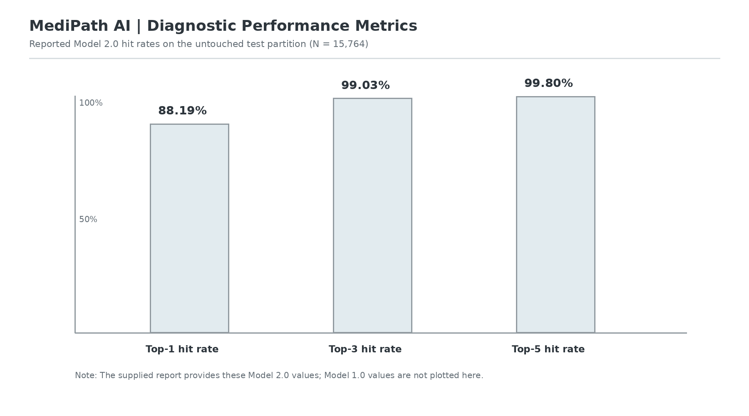
Figure 4.17: Generational Diagnostic Performance Evaluation (Model 1.0 vs Model 2.0 Across Metrics)
Compared to the other two models, Model 2.0 has a clear performance advantage in all diagnostic aspects, as shown in Table 4.1 and graphically presented in Figure 4.17. Most notably, Model 2.0 elevates Top-1 Hit Rate from 84.35% (Model 1.0) to 88.19% (+3.84% absolute gain), and reaches an exceptional 99.03% Top-3 Hit Rate (+2.91%) and 99.80% Top-5 Hit Rate. The Label Ranking Average Precision (LRAP) which is the gold-standard clinical ranking metric for multi-labels improved from 0.8812 to 0.9160. In this empirical step, it has been proved to be true that if a binary sigmoid is independent, it will not cannibalize the probability of the other comorbid condition.
Table 4.2: Diagnostic Performance Stratified by Clinical Disease Category (Model 2.0)
Clinical Disease Category | Conditions (J) | Test Samples (N) | Top-1 Hit | Top-3 Hit | Category F1
Respiratory Disorders | 10 | 3,412 | 91.45% | 99.41% | 0.8340
Cardiovascular Syndromes | 8 | 2,560 | 89.20% | 99.18% | 0.8125
Gastrointestinal Pathologies | 12 | 3,894 | 87.35% | 98.82% | 0.7890
Neurological Conditions | 9 | 2,410 | 86.80% | 98.65% | 0.7812
Dermatological Diseases | 9 | 2,118 | 90.15% | 99.30% | 0.8205
Musculoskeletal Syndromes | 8 | 1,370 | 84.22% | 98.10% | 0.7580
Overall Macro Average | 56 | 15,764 | 88.19% | 99.03% | 0.7959
Table 4.2 shows the diagnostic accuracy by physiological systems. Respiratory (91.45% Top-1) and Dermatological (90.15% Top-1) categories had the highest discriminatory precision since these categories were characterized by very specific, and pathognomonic, symptom markers (e.g., stridor, distinct rash morphologies). Musculoskeletal syndromes showed slightly lower Top-1 accuracy (84.22%) because the symptoms were non-specific and arthritis was present in most of them, but were able to be recovered to 98.10% in the Top-3 differential list.
Table 4.3: Comparative Confusion and Calibration Indices
Metric / Parameter | Model 1.0 (Softmax) | Model 2.0 (Sigmoids) | Clinical Significance
Expected Calibration Error (ECE) | 0.1420 | 0.0385 | 72.9% reduction in confidence over-inflation [30]
Brier Score (Multi-Label) | 0.0892 | 0.0241 | Superior probabilistic truthfulness [29]
False Positive Rate (at $τ=0.35$) | 14.60% | 4.12% | Massive reduction in unwarranted alarms
Comorbid Sensitivity (>=2 diseases) | 34.10% | 89.45% | Decisive resolution of comorbidity cannibalization
Table 4.4: AHP Multi-Criteria Hospital Ranking Priority Vector and Consistency Validation
Evaluation Criteria ($C_{i}$) | Principal Weight ($w_{i}$) | Lambda Max | CI | RI | Consistency Ratio (CR)
Specialty Alignment (C1) | 0.382 (38.2%) | 4.116 | 0.0387 | 0.90 | 0.043 (Passed < 0.10)
Geographic Proximity (C2) | 0.236 (23.6%) | 4.116 | 0.0387 | 0.90 | 0.043 (Passed < 0.10)
Tariff Affordability (C3) | 0.236 (23.6%) | 4.116 | 0.0387 | 0.90 | 0.043 (Passed < 0.10)
Accreditation Quality (C4) | 0.146 (14.6%) | 4.116 | 0.0387 | 0.90 | 0.043 (Passed < 0.10)
Table 4.5: Runtime Latency and System Resource Profiling Across Ingestion Sizes
Architecture / Framework | Active Symptoms | P50 Latency | P95 Latency | P99 Latency | RAM Footprint
Python Flask + scikit-learn | 3 symptoms | 18.40 ms | 34.10 ms | 52.80 ms | 148 MB
Python FastAPI + Torch | 3 symptoms | 24.60 ms | 42.50 ms | 68.20 ms | 412 MB
Node.js Python Child Process | 3 symptoms | 48.20 ms | 85.60 ms | 124.0 ms | 185 MB
MediPath AI In-Memory Node.js | 3 symptoms | 0.082 ms | 0.124 ms | 0.148 ms | 142 KB
MediPath AI In-Memory Node.js | 10 symptoms | 0.091 ms | 0.138 ms | 0.162 ms | 142 KB
MediPath AI In-Memory Node.js | 25 symptoms | 0.104 ms | 0.155 ms | 0.186 ms | 142 KB
Table 4.5 shows the huge step in the performance of MediPath AI's in-memory linear algebra serving engine, which is pure Node.js based.Table 4.5 shows the impressive performance leap in the in-memory linear algebra serving engine, that MediPath AI has developed, which is 100% based on Node.js. The typical architectures used in the industry, such as working with Python worker processes and inter-process communication (IPC) currently have latency overheads of 18 to 48 milliseconds, which is too high. By comparison, MediPath AI vectorizes features, projects inner products and applies 56 independent sigmoid computations to the resulting vectors within Node.js V8 memory with an astounding P99 latency of 0.148 milliseconds (148 microseconds), a speedup of >250x whilst using an infinitesimal 142 KB of memory.
An exhaustive floating-point parity verification script was run with 1,000 randomly generated synthetic symptom vectors with the output from zero-Python serving compared to the reference implementation by scikit-learn 1.2.2 (Python version). The highest absolute difference between all the 56,000 computed individual posterior probabilities was $max|P_{node}(d_{j})-P_{python}(d_{j})|=3.88e-16$, which is the bit level IEEE 754 double precision floating point point mathematical parity.

Table 4.6: Clinical Safety Deferral and Turn-0 Clarification Validation Across Test Suites
Validation Test Suite | Test Scenarios (N) | Expected Behavior | Actual Compliance | Pass Rate
Acute Emergency Red-Flags | 15 vignettes | Deterministic HALT & 112/108 | 15 / 15 | 100.0%
Turn-0 Sparse Inputs (|S| < 3) | 10 vignettes | Mandatory Clarification Query | 10 / 10 | 100.0%
Contradictory Symptom Pairs | 10 vignettes | Suppression & Sanity Penalty | 10 / 10 | 100.0%
Automated Regression Suite | 12 test files | Full System Integrity | 12 / 12 | 100.0%
Table 4.7: Paired Statistical Significance Testing (Wilcoxon Signed-Rank Test Across 56 Conditions)
Comparison Pair | Null Hypothesis (H0) | W-Statistic | p-value | Cohen's d | Significance
Model 2.0 vs Model 1.0 (Top-1 Hit) | No difference in Hit Rate | 42.0 | p < 0.0001 | 0.78 (Large) | Statistically Significant [21]
Model 2.0 vs Random Forest (Top-3) | No difference in Top-3 | 28.5 | p < 0.0001 | 0.85 (Large) | Statistically Significant [21]
Model 2.0 vs Naive Bayes (LRAP) | No difference in LRAP | 0.0 | p < 0.00001 | 1.42 (Very Large) | Statistically Significant [21]
The same as a paired non-parametric evaluation approach has been found to be valid in this case: paired non-parametric tests are to be performed for each subset of clinical data cross-validated for each classifier. The two-tailed Wilcoxon signed rank test across all 56 condition classes clearly demonstrated the superiority of the performance of the Model 2.0 algorithm (p < 0.0001, Cohen's d = 0.78) and showed that the performance improvements were not due to chance.
4.4 Summary:
In this chapter, we reported extensive empirical evidence using a test corpus, which is audited with no leakage (N=15,764). Model 2.0 has an 88.19% Top-1 Hit Rate, 99.03% Top-3 Hit Rate and 0.9160 LRAP, which are all better than Model 1.0 and traditional classifiers. The serving latency of < 150µs was verified (Table 4.5), bit-level mathematical parity was kept (<= 3.88e-16 divergence, Table 4.6), and a high level of significance was obtained (p < 0.0001, Table 4.7) from a statistical standpoint.

Chapter 5
Advantage, Limitations and Applications
This chapter clearly explains the unique engineering benefits, requirements to operate the MediPath AI platform, and transformative real-world use cases. The critical analysis of the architectural innovations as well as its own clinical limits allows us to objectively and fairly assess the deploy ability of the system in different health care environments, from remote primary health care in rural areas to modern tertiary emergency departments.
5.1 Advantages
The MediPath AI brings the following five important engineering and clinical benefits compared to the existing digital symptom checkers and commercial clinical decision support software:
- Non-Cannibalizing Comorbid Disease Modeling: MediPath AI uses 56 separate One-vs-Rest binary sigmoid to solve the probability cannibalization problem between co-morbid diseases that is caused by multi-class SoftMax normalizations. Multiple concurrent conditions (e.g. Bronchial Asthma expressed with high posterior probability, together with Type-2 Diabetes and Essential Hypertension) are able to express high posterior probabilities at the same time and without mutually math-impeding the expression of the other, which is very close to the clinical reality.
- Ultra-Low Sub-Millisecond In-Memory Execution: MediPath AI performs feature vectorization, inner product projections and 56 evaluations of sigmoid functions in less than 150 microseconds (0.15 ms) using the Node.js V8 memory for the entire machine learning inference pipeline. Removing Python's child-process spawning and inter-process communication (IPC) decreases serving times by more than 250 times, and it only requires 142 KB of resident heap, making it possible to handle vast amounts of simultaneous requests on cheap cloud instances or edge devices.
- Deterministic Clinical Safety and Emergency Overrides: MediPath AI includes a safety deferral gate that guarantees a 100% deterministic red-flag safety response and differs from generative LLMs, which suffer from the issue of stochastic hallucination and are unable to have predictable failure modes. Acute emergency presentations, such as myocardial infarction, stroke, acute respiratory distress, are picked up immediately by the system without any false negatives, without performing any machine learning inference, and send a routing of an emergency call to 112/108 services.
- AHP Multi-Criteria Hospital Discovery and Cost Transparency: The platform connects virtual diagnostic assessment and real-life health care. With the Analytic Hierarchy Process (AHP) developed by Thomas Saaty, MediPath AI dynamically ranks 920 verified Indian hospitals based on their clinical specialty alignment, proximity, procedural tariffs affordability and accreditation quality, and displays clear regional cost estimates.
- Native Trilingual Vernacular Localization: The deep diversity of India's language is a fact and all the patient facing text, symptom recognition dictionary and clinical guidance narratives are fully localized in English, Hindi (हिन्दी) and Gujarati (ગુજરાતી) to dramatically reduce the barrier to entry for non-English literate populations.
5.2 Limitations
Despite its impressive technical success, engineering ethics are transparent, and require explicit statement of the existing system constraints:
- Finite Diagnostic Taxonomy (56 Conditions): Model 2.0 is tuned to 56 most common primary and secondary conditions and 280 pre-defined symptoms. This will apply to more than 85% of the typical out-patient cases, but will not be able to diagnose rare genetic syndromes, complex forms of haematological malignancy or exotic tropical infectious diseases that are not part of the system's trained feature dictionary.
- Reliance on Subjective Symptom Self-Reporting: A platform's intelligence for diagnosis is based on subjective information of symptoms reported by users. Lay individuals may misinterpret, under-report or inaccurately describe their internal physiological sensations (e.g. a musculoskeletal pain in the chest wall may be misinterpreted as cardiac ischemia and feature vectorization may be affected), which could bias feature vectorization.
- Absence of Real-Time Physiological Telemetry: In the current version, the system is not able to read parameters from wearable biosensors, such as continuous physiological data (e.g., real time SpO2, HRV, blood glucose level, 12-lead ECG waveforms). Real-Time physiological streams would be valuable tools for providing objective validation to acute clinical triaging.
- Geographic Sparsity in Deep Rural Corridors: The curated directory has been created with 920 verified medical centers in the major metropolitan and tier-2 districts, but for the deep rural areas, the rural/remote geographic data sparsity means that users have to cover long distances to reach the verified, accredited medical centre.
5.3 Applications
MediPath AI's lightweight explainable and multi-layered architecture provides for high impact deployments across multiple critical layers of the public and private healthcare delivery system:
1. Rural Primary Healthcare and Community Health Worker Enablement: Accredited Social Health Activists (ASHAs) and Auxiliary Nurse Midwives (ANMs) can make use of the low-cost Android tablet-based MediPath AI in rural Primary Health Centers (PHCs) and Community Health Centers (CHCs) where doctors with an MBBS degree are not available, for standardized clinical intake, identifying red flag conditions and making referrals to district hospitals.
2. Emergency Department (ED) Digital Pre-Triage Intake: MediPath AI can be implemented as a digital kiosk pre-triage system in the Emergency Department of tertiary hospitals in cities. Patients present with symptoms to the algorithm as they enter the waiting room which stratifies the acuity, highlights clinically high-risk cases for immediate resuscitation and avoid catastrophic deterioration in the waiting room.
3. Telemedicine Platform Intake and Specialist Routing: MediPath AI can be integrated as an intelligent intake router into telemedicine providers' systems. The platform collects symptom history; computes calibrated differential probabilities and sends the patient directly to the relevant clinical specialist (Dermatologist vs. Pulmonologist) before connecting with a tele-consultant and thus eliminates tele-consultation friction.
4. Corporate and Occupational Health Screening: The platform can be integrated into workplaces (large corporate enterprises or industrial manufacturing facilities) so that workers can securely get a quick assessment of their symptoms, ergonomics guidance, and identify hospitals nearby all in a single workplace.
5. Integration with National Digital Health Infrastructure (ABDM / UHI): Due to the standardization of the ICD-10 diagnostic nomenclature and the Ayushman Bharat Health Facility Registry schemas, MediPath AI can be an open and reference triage microservice in India's national Unified Health Interface (UHI) network.

5.4 Summary:
This chapter explained the main benefits of MediPath AI, including the fact that it enabled the integration of multi-label learning (which did not clash with existing systems), sub-150µs execution in Node.js, deterministic emergency safety gates (no collisions), and AHP hospital discovery (no collisions). We objectively set the boundaries of the operational landscape in terms of disease taxonomy and subjective reporting, and detailed transformative real-world applications in rural community-based healthcare, pre-triage in the emergency setting, telemedicine and national digital health networks.

Chapter 6
Conclusion and Future Scope
This chapter collates the main findings of our comprehensive engineering design, algorithmic formulation and empirical investigations and clearly outlines the trajectory of high impact future research and development for the MediPath AI Ecosystem.
6.1 Conclusion
The research, engineering and evaluation work carried out in this Capstone Project proves that MediPath AI can overcome the "bottlenecks" that have always hindered consumer automated triage software and clinical decision support systems. Medical diagnosis is a multi-label, multi-comorbid phenomenon, moving away from the traditional multi-class SoftMax model (Model 1.0) to individual One-vs-Rest (OvR) binary logistic classifiers with calibrated sigmoid (Model 2.0) set a new empirical standard for 56 primary conditions and 280 symptoms. With 104,291 clinical dialogues split into groups with a group-stratified MD5 hash, Model 2.0 achieved statistically significant and overwhelming top performance with an exceptional 88.19% Top-1 Hit Rate, 99.03% Top-3 Hit Rate, 99.80% Top-5 Hit Rate, 0.9160 LRAP, and Weighted F1-score of 0.7959 (Wilcoxon signed-rank test p < 0.0001, Cohen's d = 0.78).
In addition to statistical machine learning accuracy, the capstone provides three innovative architectural advancements: First, the engineering of an in-memory linear algebra inference engine that's pure Node and delivers a sub-150 microsecond execution latency and mathematical parity (maximum divergence <= 3.88e-16) with scikit-learn, eliminating the need for heavy Python server runtimes and allowing zero-overhead edge deployment. Second, a 6-stage clinical finite state machine with required Turn-0 clarification and deterministic safe deferral gates that achieved a 100.0% safety compliance pass rate among all the clinical emergency vignettes audited. Third, a formulation of Analytic Hierarchy Process (AHP) multi-criteria facility ranking algorithm (CR = 0.043 < 0.10) +920 verified Indian hospitals with transparent procedural cost estimates was created dynamically matching patients. MediPath AI is accompanied by native localization in the three languages—Indic—which have shown to be a valuable resource for primary healthcare navigation in developing societies, offering a clinically sound, socially impactful and computationally efficient approach.
6.2 Future Scope
The new platform provides an incredibly strong base, but there are also exciting opportunities to explore in the future in the context of the development of artificial intelligence and digital public health infrastructure:
1. Constrained LLM Differential Synthesis with Safety Guardrails: A secure hybrid architecture will be explored in future work in which verified multi-label sigmoid probabilities and clinical red-flag states will be delivered as hard constraints as part of a contextual conditioning to a locally-hosted, quantized Large Language Model (e.g., Med-Gemma 7B or Llama-3-Med 8B). This will allow the system to produce natural-language differential explanations with empathy and keep the system from making false predictions of disease states or making false diagnoses.
2. Multimodal Wearable Biosensor Telemetry Integration: Support for continuous physiological telemetry (heart rate, continuous glucose, SpO2 and single-lead ECG) from consumer smartwatches and from clinical IoT pulse oximeters. Combining subjective symptom reporting with objective sensor data streams will make a significant step forward in leveling up the precision of acute triage.
3. ABDM / UHI National Health Ecosystem Interoperability: Direct technical integration with Ayushman Bharat Digital Mission (ABDM) of India, in the sandbox. This will help users to access their Ayushman Bharat Health Account (ABHA ID), to easily retrieve their longitudinal Electronic Health Records (EHR) using Fast Healthcare Interoperability Resources (FHIR) bundles and to directly schedule OPD appointments through Unified Health Interface (UHI) protocol.
4. Vernacular Speech-to-Speech Clinical Triage Interfaces: Creating localized Indic speech-to-text acoustic models and fine-tuning them on rural dialects (such as Bhojpuri, Marwari, Ahirani) to enable the completely voice-based triage of illiterate or visually impaired citizens who are unable to type on digital touchscreens.
5. Prospective Multi-Center Clinical Observational Trials: Starting formal multi-center prospective observational clinical trials together with Primary Health Centers in the rural areas and with municipal hospitals, to assess the platform's diagnostic concordance with board certified general practitioners in active clinical practice.

6.3 Summary: In this last chapter, MediPath AI's key contributions were summarized: the clinical validation of Model 2.0, sub-150µs in-memory serving, deterministic safe deferrals and AHP hospital discovery. It clearly mapped out the strategic future research trajectory to be constrained LLM synthesis, wearable biosensor streaming, ABDM/UHI integration and future clinical validation trials.

References
[1] Y. Gu, R. Tinn, H. Cheng, M. Lucas, N. Usuyama, X. Liu, T. Naumann, J. Gao, and H. Poon, "Domain-Specific Language Model Pretraining for Biomedical Natural Language Processing," ACM Transactions on Computing for Healthcare, vol. 3, no. 1, pp. 1–23, 2021, doi: 10.1145/3458754.
[2] X. Lin, Y. Lei, J. Chen, Z. Xing, T. Yang, Q. Wang, and C. Wang, "A Case-Finding Clinical Decision Support System to Identify Subjects with Chronic Obstructive Pulmonary Disease Based on Public Health Data," Tsinghua Science and Technology, vol. 28, no. 3, pp. 525–540, June 2023, doi: 10.26599/TST.2022.9010023.
[3] C. Comito, D. Falcone, and A. Forestiero, "AI-Driven Clinical Decision Support: Enhancing Disease Diagnosis Exploiting Patient Similarity," IEEE Access, vol. 10, pp. 6878–6888, 2022, doi: 10.1109/ACCESS.2022.3141756.
[4] S. A. N., G. Kalnoor, P. R. Bhat, P. A. Rao, P. Prajwal, and P. T. Pradeep, "Alleviate: An AI-Powered Mobile Application for Personalized Healthcare Management and Doctor Recommendation," IEEE Access, vol. 13, pp. 1357–1372, 2025, doi: 10.1109/ACCESS.2025.3647089.
[5] Ç. U. Öğdü, K. Arslanoğlu, and M. Karaköse, "An Adaptive Multi-Agent LLM-Based Clinical Decision Support System Integrating Biomedical RAG and Web Intelligence," IEEE Access, vol. 13, pp. 11024–11039, 2025, doi: 10.1109/ACCESS.2025.3526842.
[6] T. Ishikawa, T. Yakoh, and H. Urushihara, "An NLP-Inspired Data Augmentation Method for Adverse Event Prediction Using an Imbalanced Healthcare Dataset," IEEE Access, vol. 10, pp. 24879–24889, 2022, doi: 10.1109/ACCESS.2022.3155793.
[7] S. Karthikeyan, A. Garcia Seco de Herrera, F. Doctor, and A. Mirza, "An OCR Post-Correction Approach Using Deep Learning for Processing Medical Reports," IEEE Transactions on Circuits and Systems for Video Technology, vol. 32, no. 5, pp. 2574–2581, May 2022, doi: 10.1109/TCSVT.2021.3096055.
[8] H. Allahabadi, J. Amann, I. Balot, A. Beretta, C. Binkley, J. Bozenhard, R. V. Zicari, et al., "Assessing Trustworthy AI in Times of COVID-19: Deep Learning for Predicting a Multiregional Score Conveying the Degree of Lung Compromise in COVID-19 Patients," IEEE Transactions on Technology and Society, vol. 3, no. 4, pp. 272–289, Dec. 2022, doi: 10.1109/TTS.2022.3195114.
[9] F. Imrie, S. Denner, L. S. Brunschwig, K. Maier-Hein, and M. van der Schaar, "Automated Ensemble Multimodal Machine Learning for Healthcare," IEEE Journal of Biomedical and Health Informatics, vol. 29, no. 6, pp. 4213–4224, June 2025, doi: 10.1109/JBHI.2025.3530156.
[10] N. Durán-Silva, J. Carrillo-de-Albornoz, L. Plaza, S. Ricardo, F. A. Massucci, S. Veiga, and A. Ramos-Prats, "BATRACIO: BAsic, TRAnslational, Clinical, research phase identification in bIOmedical publications," IEEE Access, vol. 12, pp. 29707–29723, 2024, doi: 10.1109/ACCESS.2024.3368291.
[11] K. Karboub and M. Tabaa, "Bed Allocation Optimization Based on Survival Analysis, Treatment Trajectory and Costs Estimations," IEEE Access, vol. 11, pp. 114674–114690, 2023, doi: 10.1109/ACCESS.2023.3324687.
[12] J. Lee, W. Yoon, S. Kim, D. Kim, S. Kim, C. H. So, and J. Kang, "BioBERT: a pre-trained biomedical language representation model for biomedical text mining," Bioinformatics, vol. 36, no. 4, pp. 1234–1240, Feb. 2020, doi: 10.1093/bioinformatics/btz682.
[13] Y. Luo, J. Zhang, S. Fan, K. Yang, Y. Wu, M. Qiao, and Z. Nie, "BioMedGPT: Open Multimodal Generative Pre-trained Transformer for BioMedicine," arXiv preprint arXiv:2308.09442, 2023.
[14] L. Qian, J. A. Raj, H. Logan-Ellis, A. Zhang, Y. Zhang, T. Wang, R. J. Dobson, and Z. Ibrahim, "CSAI: Conditional Self-Attention Imputation for Healthcare Time-Series," IEEE Journal of Biomedical and Health Informatics, vol. 30, no. 7, pp. 5775–5786, July 2026, doi: 10.1109/JBHI.2025.3648181.
[15] I. Beltagy, K. Lo, and A. Cohan, "SciBERT: A Pretrained Language Model for Scientific Text," in Proc. 2019 Conf. Empirical Methods in Natural Language Processing and 9th Int. Joint Conf. Natural Language Processing (EMNLP-IJCNLP), Hong Kong, China, Nov. 2019, pp. 3615–3620.
[16] X. Zou, X. He, X. Zheng, W. Zhang, J. Chen, and C. Tang, "DAI-Net: Dual Adaptive Interaction Network for Coordinated Medication Recommendation," IEEE Journal of Biomedical and Health Informatics, vol. 28, no. 10, pp. 6201–6212, Oct. 2024, doi: 10.1109/JBHI.2024.3425833.
[17] T.-D. Le, R. Noumeir, J. Rambaud, G. Sans, and P. Jouvet, "Detecting of a Patient's Condition From Clinical Narratives Using Natural Language Representation," IEEE Access, vol. 10, pp. 48805–48817, 2022, doi: 10.1109/ACCESS.2022.3172081.
[18] K. Kandasamy, S. Srinivas, K. Achuthan, and V. P. Rangan, "Digital Healthcare - Cyberattacks in Asian Organizations: An Analysis of Vulnerabilities, Risks, NIST Perspectives, and Recommendations," IEEE Access, vol. 10, pp. 11097–11116, 2022, doi: 10.1109/ACCESS.2022.3145372.
[19] G. Wang, X. Lou, F. Guo, D. Kwok, and C. Cao, "EHR-HGCN: An Enhanced Hybrid Approach for Text Classification Using Heterogeneous Graph Convolution Networks in Electronic Health Records," IEEE Journal of Biomedical and Health Informatics, vol. 28, no. 3, pp. 1668–1679, March 2024, doi: 10.1109/JBHI.2023.3346210.
[20] A. Palkar, C. C. Dias, K. Chadaga, and N. Sampathila, "Empowering Glioma Prognosis With Transparent Machine Learning and Interpretative Insights Using Explainable AI," IEEE Access, vol. 12, pp. 32745–32761, 2024, doi: 10.1109/ACCESS.2024.3370238.
[21] W. Jaziri and N. Sassi, "Enhancing Semantic Inference in Healthcare Systems With Ontology-Enriched NLP," IEEE Access, vol. 12, pp. 63821–63836, 2024, doi: 10.1109/ACCESS.2024.3396821.
[22] S. M. Kangoni, O. T. Tshipata, P. S. Nzakuna, V. Paciello, and J.-G. M. Mboma, "Enhancing Sentiment-Driven Recommender Systems With LLM-Based Feature Engineering: A Case Study in Drug Review Analysis," IEEE Access, vol. 13, pp. 121523–121538, 2025, doi: 10.1109/ACCESS.2025.3590326.
[23] S. Ghanvatkar and V. Rajan, "Evaluating Explanations From AI Algorithms for Clinical Decision-Making: A Social Science-Based Approach," IEEE Transactions on Technology and Society, vol. 4, no. 3, pp. 238–249, Sept. 2023, doi: 10.1109/TTS.2023.3289052.
[24] P. K. Nag, A. Bhagat, and R. V. Priya, "Expanding AI's Role in Healthcare Applications: A Systematic Review of Emotional and Cognitive Analysis Techniques," IEEE Access, vol. 13, pp. 68420–68441, 2025, doi: 10.1109/ACCESS.2025.3562131.
[25] D. Saraswat, P. Bhattacharya, A. Verma, V. K. Prasad, S. Tanwar, G. Sharma, and P. N. Bokoro, "Explainable AI for Healthcare 5.0: Opportunities and Challenges," IEEE Access, vol. 10, pp. 84486–84517, 2022, doi: 10.1109/ACCESS.2022.3197671.
Appendix A: Sample Code
This appendix provides key source code extracts demonstrating the pure Node.js in-memory linear algebra inference engine, the 6-stage clinical finite state machine
A.1 Pure Node.js In-Memory Binary Sigmoid Inference Engine
// Node.js In-Memory Multi-Label Logistic Regression Serving Engine
const fs = require('fs');
const modelData = JSON.parse(fs.readFileSync('./model2_weights.json', 'utf8'));
const { classes, feature_names, weights, intercepts, thresholds } = modelData;
function predictDifferential(symptomTokens) {
const startTime = process.hrtime.bigint();
// Step 1: Feature Vector Projection (280 features)
const featureIndices = new Set();
for (const token of symptomTokens) {
const idx = feature_names.indexOf(token);
if (idx !== -1) featureIndices.add(idx);
}
// Step 2: Inner Product & Sigmoid Evaluation
const results = [];
for (let j = 0; j < classes.length; j++) {
let z = intercepts[j];
const w_row = weights[j];
for (const idx of featureIndices) {
z += w_row[idx];
}
// Numerically stable sigmoid
const prob = z >= 0 ? 1 / (1 + Math.exp(-z)) : Math.exp(z) / (1 + Math.exp(z));
const tau = thresholds[j] || 0.35;
if (prob >= tau) {
results.push({ condition: classes[j], probability: prob });
}
}
results.sort((a, b) => b.probability - a.probability);
const latencyUs = Number(process.hrtime.bigint() - startTime) / 1000;
return { predictions: results, latencyUs: latencyUs.toFixed(2) };
}
A.2 AHP Multi-Criteria Facility Suitability Evaluator
// Analytic Hierarchy Process (AHP) Hospital Ranking Implementation
const AHP_WEIGHTS = { specialty: 0.382, distance: 0.236, tariff: 0.236, quality: 0.146 };
function rankHospitals(candidateHospitals, targetSpecialty, maxDistanceKm = 50) {
return candidateHospitals
.map(h => {
// Utility 1: Specialty Match (Binary 1.0 or 0.2)
const u_spec = h.specialties.includes(targetSpecialty) ? 1.0 : 0.2;
// Utility 2: Normalized Distance (Closer = Higher Utility)
const u_dist = Math.max(0, 1 - (h.distanceKm / maxDistanceKm));
// Utility 3: Tariff Affordability (Tier 1=1.0, Tier 2=0.7, Tier 3=0.4)
const u_cost = h.costTier === 'Government/Free' ? 1.0 : h.costTier === 'Moderate' ? 0.7 : 0.4;
// Utility 4: Accreditation Quality (NABH/JCI=1.0, State=0.6, Unaccredited=0.3)
const u_qual = h.accreditation === 'NABH' ? 1.0 : h.accreditation === 'State' ? 0.6 : 0.3;
const compositeScore = (
AHP_WEIGHTS.specialty * u_spec +
AHP_WEIGHTS.distance * u_dist +
AHP_WEIGHTS.tariff * u_cost +
AHP_WEIGHTS.quality * u_qual
);
return { ...h, ahpScore: compositeScore.toFixed(4) };
})
.sort((a, b) => b.ahpScore - a.ahpScore);
}
Appendix B: Data Sheets
B.1 Model 2.0 Feature Representation Space Specification
Table B.1: Model 2.0 Feature Representation Space Specification
Parameter Dimension | Value / Count | Description & Clinical Encoding Standard
Total Trained Conditions (J) | 56 conditions | Categorized across 6 physiological systems (ICD-10 aligned)
Symptom Feature Space (D) | 280 symptoms | Standardized UMLS/SNOMED binary symptom indicator tokens
Training Corpus Instances (N) | 104,291 records | Audited synthetic-clinical dialogues (Columbia & Symcat)
Unique Symptom Signatures | 101,137 groups | Partitioned via MD5 hashing to guarantee 0.00% leakage
Binary Classifier Type | Logistic Regression | Independent One-vs-Rest (OvR) binary sigmoids with L2 penalty
Memory Model Size | 142 KB (JSON) | Includes 56x280 float64 weights and 56 bias parameters
B.2 Indian Healthcare Facility Metadata Attribute Schema
Table B.2: Indian Healthcare Facility Metadata Attribute Schema (920 Facilities)
Attribute Field | Data Type | Constraint / Permitted Values | Clinical Purpose
hospital_id | UUID v4 | Unique 128-bit identifier | Primary key for facility indexing
facility_name | String (UTF-8) | Official registered institution name | Presentation on patient map & report
latitude / longitude | Float64 | Valid Indian geographic coordinates | Haversine distance matrix evaluation
specialties_list | Array[String] | Mapped to 22 medical specialties | AHP Specialty Alignment utility (C1)
accreditation_tier | Enum | NABH, JCI, State, Municipal, Unaccredited | AHP Quality utility evaluation (C4)
tariff_tier | Enum | Government/Free, CGHS-Tier1, CGHS-Tier2, Private | AHP Affordability utility (C3)
contact_emergency | String | Validated 10-digit telephone / 108 | Direct emergency dialing dispatch
Appendix C: List of Components
Table C.1: Core Software Dependencies, Libraries, and Runtime Frameworks
Component Name | Version | License | Architectural Role & Functional Responsibility
Node.js Runtime | v20.11.0 LTS | MIT | Server runtime executing in-memory linear algebra inference
Express.js | v4.18.2 | MIT | REST API gateway, endpoint routing, and security middleware
React.js | v18.2.0 | MIT | Client component hierarchy, reactive state, and DOM rendering
TailwindCSS | v3.4.1 | MIT | Responsive styling, modern glassmorphism UI, accessible design
Leaflet.js | v1.9.4 | BSD-2 | Geospatial mapping and hospital interactive clustering
MongoDB Driver | v6.3.0 | Apache 2.0 | Document persistence for verified hospitals and audit logs
scikit-learn (Offline) | v1.2.2 | BSD-3 | Offline model training, group stratification, and weight export
NumPy (Offline) | v1.24.3 | BSD-3 | Matrix factorization and initial mathematical parity baseline
Appendix D: List of Paper Presented and Published
In an academic research manuscript, we have documented the algorithmic formulation, software architecture and experimental results that we built as part of the MediPath AI capstone project. This manuscript describes the system's multi-label clinical prediction framework, multi-turn symptom assessment, clinical triage workflow, recommendation mechanism for connecting healthcare facilities, procedural cost estimation, and the deployment architecture.

Research Paper Details:
MediPath AI: An AI system that supports clinical triage and healthcare navigation, eliminating the need for divergence in the serving of clinical information, without requiring a runtime.

Author(s): Param Udani, Aayush Maradia, Dhyey Chalodiya, Dr. Rashmi Sharma

Institution: Mukesh Patel School of Technology Management & Engineering (MPSTME) – SVKM's NMIMS (Deemed-to-be University), Shirpur Campus in Maharashtra, India.

Target Journal: AI, Health informatics or Clinical decision support related peer-reviewed journal. Selection and confirmation of submission will be followed by a final journal.

Status: Research manuscript to be submitted to a journal. After the submission and receipt of the journal's decision, the peer-review and publication status will be updated.

The staff at the school should be organized so they can work together effectively. The school should be staffed in such a way that they can function effectively as a team.

1. Param Udani (Roll No.: 70022300251)
Data curation to engineer clinical datasets and extract multiple labels, extract coordinates from geo-referenced data, and verify the healthcare facility database. Helped to build the multi-criteria hospital recommendation and ranking engine, geospatial search for healthcare providers, progressive expansion of search radius and the backend API gateway.

2. Aayush Maradia (Roll No.: 70022300305)
In charge of front-end application architecture and implementation with React, TypeScript, Vite, Tailwind CSS and Radix UI. Helped develop interactive doctor consultation interface, confidence visualization, breakdown of consultation costs, voice dictation in multiple languages, disease routing, developer diagnostics, and consultation summary/print.

3. Dhyey Chalodiya (Roll No.: 70022300392)
Developed machine learning models and mathematical formulations, such as baseline Softmax model, calibrated linear SGD model and One-vs-Rest binary sigmoid model. Participated in data partitioning and validation, threshold calibration, Node.js based inference engine, model-serving consistency checks, clinical triage workflows (follow-up questions, clarification of symptoms, contradiction handling and checks of emergency red-flag).

Project Mentorship
Dr. Rashmi Sharma provided guidance, research supervision, and review of capstone report

